2025 HSC EOY Notes
HSC Software Engineering NOTES
Xujing (James) Mao
TKS

Table of Contents
Syllabus 5
Secure Software Architecture 5
Describe the benefits of developing secure software, including data protection and minimising cyber-attacks and vulnerabilities. 5
Interpret and apply fundamental software development steps to develop secure code, including requirements definition, determining specifications, design, development, integration, testing and debugging, installation and maintenance. 6
Describe how the capabilities and experience of end users influence the secure design features of software. 9
When developing programming code, explore fundamental software design security concepts, including confidentiality, integrity, availability, authentication, authorisation, and accountability. 10
Apply security features incorporated into software, including data protection, security, privacy and regulatory compliance. 11
Use and explain the contribution of cryptography and sandboxing to the ‘security by design’ approach in developing software solutions. 12
Use and explain the 'privacy by design' approach in the development of software solutions, including a proactive not reactive approach, embed privacy into design, respect for user privacy 13
Test and evaluate the security and resilience of software by determining vulnerabilities, hardening systems, handling breaches, maintaining business continuity and conducting disaster recovery. 14
Apply and evaluate strategies used by software developers to manage the security of programming code, including code review, static application security testing (SAST), dynamic application security testing (DAST), vulnerability assessment and penetration testing. 16
Design, develop and implement code using defensive data input handling practices, including input validation, sanitisation and error handling. 17
Design, develop and implement a safe application programming interface (API) to minimise software vulnerabilities. 17
Design, develop, and implement code that considers efficient execution for the user, including memory management, session management, and exception management. 18
Design, develop and implement secure code to minimise vulnerabilities in user action controls, including broken authentication, session management, cross-site scripting (XSS), cross-site request forgery (CSRF), invalid forwarding and redirecting and race conditions. 18
Design, develop and implement secure code to protect user file and hardware vulnerabilities from file attacks and side-channel attacks. 19
Apply and describe the benefits of collaboration to develop safe and secure software, including considering various points of view (POV), delegating tasks based on expertise and quality of the solution. 20
Investigate and explain the benefits to an enterprise of implementing safe and secure development practices, including improved products or services, influence on future software development, productivity, and business interactivity. 20
Evaluate the social, ethical and legal issues and ramifications that affect people and enterprises resulting from the development and implementation of safe and secure software, including employment, data security, privacy, copyright, intellectual property and digital disruption. 22
Programming for the Web 24
Explore the applications of web programming, including interactive websites/webpages, e-commerce, and progressive web apps (PWAs). 24
Investigate and practise how data is transferred on the internet, including data packets. Internet Protocol (IP) addresses, including IPv4, and domain name systems (DNS). 25
Investigate and describe the function of web protocols and their ports, including HTTP, HTTPS, TCP/IP, DNS, FTP, SFTP, SSL, TLS, SMTP, POP 3, IMAP 27
Explain the processes for securing the web, including Secure Sockets Layer (SSL) certificates, encryption algorithms, encryption keys, plain text and cipher text, authentication and authorisation, hash values and digital signatures. 29
Investigate the effect of big data on web architecture, including data mining, metadata, and streaming service management. 31
Investigate and explain the role of the World Wide Web Consortium (W3C) in the development of web applications, including the Web Accessibility Initiative (WAI), internationalisation, web security, privacy, and machine-readable data. 33
Model elements that form a web development system, including client-side (front-end) web programming, server-side (back-end) web programming, and interfacing with databases that are based on Structured Query Language (SQL) or non-SQL. 34
Explore and explain the influence of a web browser on web development, including using developer tools. 35
Investigate cascading style sheets (CSS) and its impact on the design of a web application, including consistency of appearance, flexibility with browsers or display devices, and CSS maintenance tools. 37
Investigate the reasons for version control and apply it when developing web applications. 38
Explore the types and significance of code libraries for front-end web development, including frameworks that control complex web applications, template engines, and predesigned CSS classes. 38
Explain the use and development of open-source software in relation to web development. 40
Investigate methods to support and manage the load times of web pages/applications. 40
Research, experiment with and evaluate the prevalence and use of web content management systems (CMS). 42
Assess the contribution of back-end web development to the success of a web application. 42
Observe and describe the back-end process used to manage a web request, including the role of web server software, web framework, objects, libraries, and databases. 43
Develop a web application using an appropriate scripting language with shell scripts to make files and directories, and search for text in a text file. 44
Apply a web-based database and construct script that executes SQL, including selecting fields, incorporating ‘group by’, common SQL queries, constraints using WHERE keyword, and table joins. 45
Compare Object-Relational Mapping (ORM) to SQL. 46
Describe how collaborative work practices between front-end and back-end developers improve the development of a web solution. 47
Design, develop and implement a progressive web app (PWA), including the application of design and user interface (UI) and user experience (UX), principles of font, colour, audio, video and navigation, and a UI that considers accessibility and inclusivity. 48
AI 51
Investigate how machine learning (ML) supports automation through the use of DevOps, robotic process automation (RPA) and business process automation (BPA). 51
Distinguish between artificial intelligence (AI) and machine learning (ML) 54
Explore models of training ML, including supervised learning, unsupervised learning, semi-supervised learning, and reinforcement learning. 54
Investigate common applications of key ML algorithms, including data analysis and forecasting, virtual personal assistants, and image recognition. 55
Research models used by software engineers to design and analyse ML, including decision trees and neural networks. 56
Describe types of algorithms associated with ML, including linear regression, logistic regression, and K-nearest neighbour. 59
Design, develop and apply ML regression models using an OOP to predict numeric values, including linear regression, polynomial regression, and logistic regression. 60
Apply neural network models using an OOP to make predictions. 60
Assess the impact of automation on the individual, society and the environment, including safety of workers, people with disability, the nature and skills required for employment, production efficiency, waste and the environment, and the economy and distribution of wealth. 61
Explore by implementation how patterns in human behaviour influence ML and AI software development, including psychological responses, patterns related to acute stress response, cultural protocols, and belief systems. 63
Investigate the effect of human and dataset source bias in the development of ML and AI solutions. 64
Software Engineering Project 67
Define and analyse the requirements of a problem, including demonstrating need(s) or opportunities, assessing scheduling and financial feasibility, generating requirements including functionality and performance, defining data structures and data types and defining boundaries. 67
Explore tools used to develop ideas and generate solutions, including brainstorming, mind-mapping and storyboards, data dictionaries, selecting appropriate data types, algorithm design, code generation, testing and debugging, installation, and maintenance. 68
Investigate types of software implementation methods, including direct, phased, parallel, and pilot. 69
Research and use the Waterfall software development approach, including logical progression of steps used throughout the life cycle, stages of ‘falling water’, advantages and disadvantages and scale and types of developments. 70
Research and use the Agile software development approach, including the rate of developing a final solution, method tailoring, iteration workflow, and scale and types of development. 71
Research the WAgile software development approach, including understanding it is a hybrid model, analysis of the ‘when’ and ‘how’ intervention is applied during the development life cycle, and scale and types of developments. 72
Apply project management to plan and conduct the development and implementation of a project and software engineering solution, including scheduling and tracking using a software tool, including Gantt charts, using collaboration tools. 73
Explore social and ethical issues associated with project work, including working individually, collaboratively and responding to stakeholders. 74
Explore communication issues associated with project work, including involving and empowering the client, enabling feedback, and negotiating. 74
Investigate how software engineering solutions are quality assured, including defining criteria on which quality will be judged, ensuring requirements are met using a continual checking process, addressing compliance and legislative requirements. 75
Other 76
Procedures and Functions 76
Errors 76
OOP, imperative, logic and functional Programmingc Paradigms 76
Compare procedural programming with OOP. 78
Encapsulation 78
Inheritance 79
Polymorphism 79
Generalisation and Abstraction 79
Stubs and Drivers 79
Skills 80
IPO 80
Structure Chart 80
Pseudocode and Flowchart 81
Key Points 81
Symbol 81
Data Flow Diagram 82
Desk Check 82
Data Dictionary 83
Class Diagram 83
Gantt Chart 84
SQL 84
ERD 85
Wiring Diagram 85
MLOps 86
Regression Model 87
Python 88

Syllabus

Secure Software Architecture

Describe the benefits of developing secure software, including data protection and minimising cyber-attacks and vulnerabilities.
Developing secure software is vital in an evolving landscape of new threats. Secure software protects sensitive information against malicious activities. It safeguards users and organisations to enhance the overall trustworthiness and reliability of the product.

Data Protection
Secure software ensures data is handled and stored to prevent unauthorised manipulation and loss.

Encryption
Encryption is converting data into a code to prevent unauthorised access. It ensures that information is only accessible to those with the correct decryption key and unreadable to anyone without it.
E.g.: AES-256 encryption

Access Control
Access controls are security measures that regulate who can view or modify data within a system, ensuring that sensitive information is only accessible to authorised individuals.
E.g.: Role-based access control to limit what students/teachers can see on Canvas pages

Data Integrity
Data integrity refers to the accuracy and consistency of data over its lifecycle. It involves protecting data from being altered or corrupted.

Minimising Cyber Attacks and Vulnerabilities
Regular Security Audits

Securing Coding Practices
Securing coding practices are a set of guidelines that developers follow to write code resistant to common vulnerabilities such as SQL injection, XSS and buffer overflows
E.g.: The usages of validation and sanitisation of data before user input gets stored

Patch Management
Patch Management is the process of regularly updating software to fix known vulnerabilities.
E.g.: An automated patch management system to ensure all software is updated with its latest security patch.

Interpret and apply fundamental software development steps to develop secure code, including requirements definition, determining specifications, design, development, integration, testing and debugging, installation and maintenance.

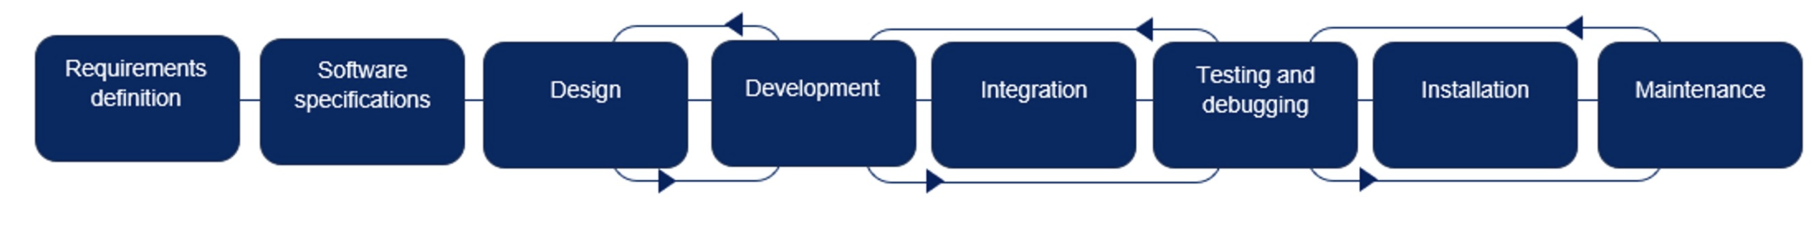

Requirement Definition
The requirement definition involves gathering and documenting the software's functional and non-functional requirements.

Client Scenario:
Understanding the client's needs and expectations regarding security features. This involves meeting the client to discuss their requirements and the security threats relevant to their context.

Environment Specifications:
Defining the operational environment, including hardware, software, and network considerations, to ensure security compatibility. This step involves assessing the current environment to identify any security gaps that must be addressed.

List of Objectives:
Creating a comprehensive list of specific, measurable security objectives that the software must achieve. E.g.: Data encryption, access controls.

Determining Specifications
Determining specifications involves creating a detailed description of the software's functionality and technical requirements, focusing on how it will meet the defined security needs.

Technical Requirements:
Defining specific technical requirements, such as encryption standards and data handling protocols, to form the backbone of robust, effective software.

Performance Criteria:
Establishing security-related performance benchmarks, such as response times for security features and the capacity to handle security events,

Compliance Standards:
Identifying and incorporating relevant security compliance standards that the software must adhere to, such as GDPR.

Input Process Output Model [IPO]:
IPO helps understand how data flows through the system and where security controls need to be applied.

Gantt Charts:
The Gantt chart provides a visual timeline of the project, helping to ensure that each task is completed on time and security milestones are met.

Design
The design phase involves creating a blueprint for the software, including architecture, data flow, and user interfaces, while embedding security principles.

System Architecture:
Designing a secure architecture that incorporates layers of security, such as firewalls, encryption, and secure access points.

Modelling Tools:
Structure Chart:
Used to represent the hierarchy and relationships between modules in the software, ensuring that secure data flow and control mechanisms are clearly defined.

Class Diagram:
Represents the system's classes, attributes, methods, and relationships, with attention to secure data handling and encapsulation of sensitive information.

Data Flow Diagram (DFD):
Maps out how data moves through the system, identifying where data must be protected during transmission and processing.

UI Design:
Ensuring the user interface supports secure interactions, including secure login processes and protection against unauthorised access.

Storyboards:
Storyboards visually represent a user’s interaction with the system to help develop UI, focusing on secure navigation and intuitive UX.

Data Dictionaries:
Develop a data dictionary to document all the data elements. The data dictionary ensures that data is consistently, efficiently and securely handled throughout the system, such as storing text in a field meant for numbers.

Pseudocode:
Pseudocode helps ensure that security measures, such as input validation and error handling, are planned and implemented correctly.

Logbooks:
Maintaining a logbook to document decisions, design changes, and security considerations throughout the design phase.

Development
The development phase is where the software is coded, with an emphasis on secure coding practices to prevent vulnerabilities.
- Secure Coding Standards
- Version Control
- Code Review

Integration
Integration involves combining individual components into a fully functioning system and ensuring that security controls work across the system. It is tested through integration testing

Testing and Debugging
Check if the program runs smoothly and fits the requirements. It involves identifying and resolving issues, focusing on uncovering security vulnerabilities.
- SAST
- DAST
- Vulnerability scanning
- Penetration Testing
- Regression Testing
- User Acceptance Testing

Installation
The installation phase involves deploying the software in a production environment. Secure configuration applied during installation helps maintain the software’s integrity and confidentiality from the start. Tests will be performed after installation to verify the functionality of the software.
E.g.: Setting strong passwords, disabling unnecessary services, and configuring firewalls

Maintenance
Maintenance involves ongoing updates and software monitoring to address new security threats.

Security Patching
Monitoring
Continuously monitoring the software for security breaches or unusual activity, allowing for a quick response.

Incident Response:
Having a plan to respond to security incidents promptly minimises the impact of any breaches.

Describe how the capabilities and experience of end users influence the secure design features of software.

Balance is needed between usability and security.

User Capability
User capabilities refer to the technical knowledge that end users possess.

Simplified Security Controls
Security features must be straightforward to use for users with limited technical skills. E.g.: Automating complex security tasks, providing clear instructions

Guided Processes
Software should guide users through security-related processes, such as setting up 2FA or managing permissions, to ensure they do not inadvertently compromise security.

Role-Based Access [RBAC]
Implementing RBAC can help tailor security features to the user's level of expertise, granting more power to experienced users while limiting potential risks for less experienced users.

User Experience
UX levels refer to users' familiarity with similar software or security practices. Users with varying experience levels may require different approaches to secure design.

Customisable Security Settings
More experienced users may prefer customisable security settings that allow them to tailor the software to their needs. E.g.: selecting encryption methods.

Default Security Settings
For less experienced users, secure default settings can protect the user without requiring extensive configuration. These settings should be robust enough to prevent common security issues while remaining easy to use.

Training and Support
Providing training materials and support options, such as tutorials or customer support services, helps users of all experience levels understand and use the software's security features.

Usability vs. Security
While security is paramount, the software must also be usable by its intended audience.

Minimising User Friction
Security features should minimise disruption to UX.
E.g.: streamlining authentication processes

Transparency of Security Features
Providing straightforward but non-intrusive notifications about security events or updates helps keep users informed without overwhelming them.

Adaptive Security
Adaptive security measures can be adjusted based on user behaviour and risk levels.
E.g.: the software might prompt additional verification if unusual activity is detected

When developing programming code, explore fundamental software design security concepts, including confidentiality, integrity, availability, authentication, authorisation, and accountability.

Confidentiality
Confidentiality ensures that sensitive information is accessible only to those authorised to view it. In web applications, this involves encrypting data and securing communications.

Integrity
Integrity ensures that data is accurate and has not been tampered with.
E.g. hashing algorithms can verify data integrity.

Availability
Availability ensures that systems and data are accessible to authorised users when needed.
E.g. rate limiting can be implemented to prevent DoS attacks.

Authentication
Authentication is the process of verifying a user's identity.
E.g: Username and password system

Authorisation
Authorisation determines what an authenticated user is allowed to do.
E.g.: RBAC system and Attribute-based access control [ABAC] system

Accountability
Accountability ensures that actions can be traced back to the responsible user.
E.g. logging user action.

Apply security features incorporated into software, including data protection, security, privacy and regulatory compliance.

Data Protection
Data protection is an approach to safeguarding data from vulnerabilities while ensuring its confidentiality, integrity, and availability. It involves implementing various security measures to protect data throughout its lifecycle, whether stored, processed, or transmitted.

Encryption - prevents unauthorised access – e.g.: AES for data storage, TLS for data transmission.

Access Controls - Ensure only authorised personnel can access sensitive data – e.g.: RBAC

Backups
Regularly back up data to secure locations to prevent data loss due to accidental deletion, corruption, or attacks like ransomware

Security
Software security protects users from threats, ensuring their data and interactions with the software remain safe. This involves implementing various security measures, such as
- Multi-factor authentication (MFA)
- Strong Passwords
- RBAC
- Access Control List [ACL]
- Client and server-side Input Validation
- Security Audits

Privacy
Privacy in secure software protects an individual's personal data and information.

Data Minimisation
Stores only what is necessary to prevent privacy breaches.

User Consent
Obtaining a user from the user client of obtaining permissions before collecting or processing data. Creating UI that has buttons or checkboxes for a consent form.

Data Access Controls

Regulatory Compliance
Achieving regulatory compliance means aligning with legal and regulatory guidelines applicable to the region.

Compliance Audits
Regularly conduct audits to ensure that the software complies with relevant regulations.

Data Retention Policies
Implement data retention policies that comply with regulations, specifying how long data is stored and when it should be deleted.

User Consent
Ensure users consent before their data is collected, processed, or shared. This is especially important for sensitive personal data.

Use and explain the contribution of cryptography and sandboxing to the ‘security by design’ approach in developing software solutions.

Security by design
The ‘security by design’ approach involves integrating security measures into the software development process rather than adding them as an afterthought.

Cryptography
Cryptography secures information by transforming it into an unreadable format that can only be deciphered with the correct key. This technique protects sensitive data and ensures its confidentiality, integrity, and authenticity.

Contribution to ‘Security by Design’:
Confidentiality
Cryptography ensures that sensitive information remains private by encrypting data to only be accessible to authorised users.

Integrity
Cryptographic techniques, such as hashing, verify that data has not been altered during transmission or storage.

Authentication
Cryptography is used in authentication processes to verify the identities of users.

Non-repudiation
Digital signatures, a form of cryptographic evidence, provide proof of the origin and integrity of data, preventing parties from denying their actions.

Sandboxing
Sandboxing is a security mechanism that isolates running processes, limiting their access to the system and preventing them from making permanent changes. Sandbox can run applications in isolation to test untrusted code in a controlled environment, containing any malicious behaviours in the sandbox without risking the entire system’s security.
E.g.: Python subprocess module

Use and explain the 'privacy by design' approach in the development of software solutions, including a proactive not reactive approach, embed privacy into design, respect for user privacy

The main principles of privacy by design help protect users’ personal information and comply with privacy regulations.

Embed privacy into design
Embedding privacy into the design means that privacy measures are integrated directly into the software's architecture, ensuring privacy is considered at every step of the development process. Personal data collection should be minimised to reduce the risk of data exposure.

Proactive, not reactive approach
Instead of reacting to privacy breaches after they have been detected, a proactive approach ensures that potential privacy issues are mitigated before they occur. In the initial stages of the software development cycle, privacy impact assessments (PIAs) are conducted to identify and evaluate potential risks.
E.g.: data anonymisation, data minimisation, encryption
- Risk Assessment
- Prevention Over Detection

Respect for user privacy
Respecting user privacy is user-centric. It means giving users active control over their data (edit, delete, export) and ensuring transparency in handling their data. Users should know how their data are collected, processed, and stored through understandable privacy policies.

E.g.:
- Provides unambiguous consent to the use of private data
- User data sharing should be limited with external third parties, ensuring confidentiality.

Test and evaluate the security and resilience of software by determining vulnerabilities, hardening systems, handling breaches, maintaining business continuity and conducting disaster recovery.

Testing and evaluating software security and resilience ensure systems remain robust against attacks and recover quickly to maintain business continuity. This process involves determining vulnerabilities, hardening systems, handling breaches, and implementing disaster recovery plans.

Determining Vulnerabilities
Vulnerabilities are weaknesses in software that attackers can exploit.

Penetration Testing [Pen Testing]
Pen Testing involves ethical hackers attempting to exploit system weaknesses to identify potential vulnerabilities before attackers do.

Automated Vulnerability Scanning
Tools like Nessus scan systems for known vulnerabilities.

Code Audits and Reviews

E.g.: Financial institutions continuously automate vulnerability scanning to detect vulnerabilities. Periodic pen testing simulates real-world attack scenarios, allowing the organisation to discover and fix vulnerabilities before attackers can exploit them.

Hardening Systems
Hardening involves securing a system by reducing its potential attack surface.

Minimising Attack Surface
Remove unnecessary services, ports, applications, and features to reduce the points of entry for attackers.

Regular Patching and Updates

E.g.: A global tech company enforces least-privilege access control policies and regularly patches its systems using automated tools.

Handling Breaches
A security breach occurs when an attacker gains unauthorised access to a system. Effectively handling a breach involves detecting, containing, and mitigating the damage caused.

Incident Response Teams [IRTs]
Dedicated teams trained to detect, contain, and mitigate security breaches. These teams follow incident response plans, which outline procedures for addressing breaches.

Containment and Mitigation
When a breach is detected, affected systems are isolated to prevent the attacker from moving laterally within the network. Mitigation involves fixing the exploited vulnerability and preventing further attacks.

Forensic Investigation
After containment, forensic investigators analyse logs to determine how the breach occurred and what data was compromised.

Maintaining Business Continuity
Business continuity ensures that operational uptime is maintained despite system disruptions.

Redundancy and Failover
Critical systems have backups that automatically take over in a failure. Cloud-based failover systems ensure that if one server goes down, another seamlessly takes over.

Data Backups
Regular backups ensure that the organisation can restore its systems in case of a data loss. Cloud backups or off-site storage ensure that data is protected even if the physical infrastructure is compromised.

Business Continuity Plans (BCPs)
BCPs outline how to maintain operations during a system outage. These plans include steps for failover, key personnel assignments, and system recovery.

E.g.:
An e-commerce platform mirrors user data with failsafe servers, routing customers through the failsafe server in case of downtime to allow customers to make purchases during system failure.

Conducting Disaster Recovery
Disaster recovery focuses on restoring systems after a significant event, such as a security breach. The aim is to recover quickly and minimise long-term impact.

Disaster Recovery Plans (DRPs)
A DRP includes the steps needed to restore critical systems and services.
- Systems are prioritised for restoration
- Resources are allocated for recovery

Backup Restoration
Backup Restoration should be tested regularly to ensure it can be used in data loss events. Offsite or cloud backups are commonly used for redundancy.

Recovery Time Objective (RTO) and Recovery Point Objective (RPO)
Organisations set goals for how quickly services must be restored (RTO) and how much data loss is acceptable (RPO). These metrics help define recovery processes and ensure that critical services are restored within acceptable timeframes.

E.g.:
A bank performs regular disaster recovery drills to ensure it can restore operations within minutes of a failure. Data is mirrored across multiple servers, ensuring that the most recent transactions can be recovered and no critical data is lost.

Apply and evaluate strategies used by software developers to manage the security of programming code, including code review, static application security testing (SAST), dynamic application security testing (DAST), vulnerability assessment and penetration testing.

Code review
Programmers overlook errors within their code. In a professional setting, colleagues run code to identify errors or mistakes, called a Code Review. Generally, these are done in the text through comments.

SAST [Static Application Testing]
SAST is a passive testing method that examines the codebase without execution. It searches for matching vulnerability patterns it has previously identified. SAST is fast and does not require time or resources to execute the program.
E.g.: Bandit on Python

DAST [Dynamic Application Testing]
DAST is a black box testing method that evaluates an application's security while running. It simulates external attacks on the application to identify vulnerabilities that attackers could exploit by sending inputs and running the application.
E.g.: OWASP ZAP

SAST | DAST
Source Code is Required | A running application is required
Vulnerabilities found earlier in development are less expensive to fix | Vulnerabilities found later in development are more expensive to fix
Unable to identify Timing and Environment-related issues | Can identify Run-Time and Environment-Related Issues.
Pre-code check-in Check | More extensive testing can be done
Nightly Scans
High compatibility with all software

Vulnerability assessment
The Vulnerability Assessment process involves identifying, quantifying, and prioritising vulnerabilities within a system.
E.g. automatic load testing and manual integration testing to test XSS Vulnerabilities

Design, develop and implement code using defensive data input handling practices, including input validation, sanitisation and error handling.

Input Validation
- Type Checking: Ensure the input is of the expected data
- Length Checking: Restrict input data length
- Range Checking: Validate that numerical inputs fall within an expected range
- Mandatory Fields: Ensure that required fields are not left blank.

Sanitisation
- Escaping characters: Replacing potentially dangerous characters (like <, >, ', etc.) with safe representations.
- Whitelist-based filtering: Accepting only known good input (e.g., allowing only alphanumeric characters for usernames).
- Converting Data Types: Command-line inputs are strings, and the code requires the type to be a number/integer for calculations.

Error Handling
In Python, error-handling messages can be used with the print() function to help log errors

Design, develop and implement a safe application programming interface (API) to minimise software vulnerabilities.

An application programming interface (API) is the intermediary that allows two software applications to interact. It includes a set of rules, protocols, and definitions that determine how API responses should be formatted.

Design, develop, and implement code that considers efficient execution for the user, including memory management, session management, and exception management.

Memory Management
Efficient memory management optimises system resources, preventing memory overconsumption and potential system crashes. Programmers should avoid creating unnecessary objects.

Session Management
Session management helps maintain user state across multiple requests. Efficient session management ensures that resources are not overused and user data is handled securely. Implementing session timeouts reduces memory consumption by closing inactive sessions. Only essential information should be stored in sessions to minimise the head.

Exception Management
Proper exception management ensures that an application can reliably handle errors without crashing or exposing sensitive information to users.
- Catch Specific Exceptions
- Log Errors for Debugging

Design, develop and implement secure code to minimise vulnerabilities in user action controls, including broken authentication, session management, cross-site scripting (XSS), cross-site request forgery (CSRF), invalid forwarding and redirecting and race conditions.

Broken Authentication
Broken authentication occurs when authentication mechanisms are not implemented securely.
E.g.: Weak password, password insecure storage, password reuse

Mitigation strategies: enforce strong password policies

Session Management
Session management controls how sessions are created, maintained, and destroyed. Insecure session management can lead to session hijacking and fixation attacks.

Mitigation strategies: Session expiration, randomly generated tokens, and hashed storage.

XSS
XSS is a client-side vulnerability where an attacker injects malicious JavaScript into a website or its backend storage. When the malicious script runs, the attacker can gain unauthorised access to sensitive information and the system.

Mitigation strategies: input sanitisation and validation, strict content security policy to restrict the execution of inline scripts

CSRF
Cross-site request forgery occurs when an attacker forges a request as an authenticated user with valid session tokens. The attacker can forge requests to interact with a malicious website and access sensitive information.

Mitigation strategies: CSRF tokens to verify the session and corresponding user actions

Invalid Forwarding and Redirection
Invalid forwarding and redirecting occur when attackers manipulate URL parameters to redirect users to unintended locations or bypass authentication.

Mitigation strategies: Restrict redirects to a predefined list of trusted URLs, implement user access controls, sanitise any user-controlled input like URLs and parameters

Race Conditions
Race conditions occur when multiple processes access and manipulate shared resources unsynchronised, leading to data corruption or unintended behaviour.

Mitigation strategies: Locking mechanisms (mutexes), atomic operations

Design, develop and implement secure code to protect user file and hardware vulnerabilities from file attacks and side-channel attacks.

File Attacks
File attacks exploit weaknesses in how a program accesses or handles files.

Buffer Overflow: Writing more data into a buffer than it can hold, causing memory corruption, which may lead to arbitrary code execution.

Side-Channel Attacks
Side-channel attacks exploit indirect information leakage, such as timing, electromagnetic emissions, or power consumption, to infer sensitive data.

Power Analysis: Observing power consumption during cryptographic operations to derive keys.

Apply and describe the benefits of collaboration to develop safe and secure software, including considering various points of view (POV), delegating tasks based on expertise and quality of the solution.

Considering various POV
Fostered by their unique specialisation and experiences, each developer on the team brings diverse solutions that reduce the risk of vulnerabilities.

E.g.: A frontend security developer might suggest adding multi-factor authentication for users. An encryption expert advocates for securing sensitive data during transmission. Together, they create a more secure system than either could have designed alone.

Delegating Tasks Based on Expertise
Effective collaboration involves knowing each team member’s strengths and delegating tasks accordingly. By assigning specific security tasks to those most qualified, you ensure that the work is done efficiently and with a higher skill level.

E.g.: A web development team assigns a developer with experience in cryptography to implement data encryption, one familiar with secure authentication to design the login flow.

Quality of Solution
When multiple developers review the same code, they are more likely to catch mistakes or suggest improvements, leading to more resilient software. Collaborative testing ensures that security features are tested adequately from multiple angles, reducing the risk of leaving potential attack vectors open.

E.g.: A team is developing a secure messaging app. After implementing E2E encryption, they collaborate on testing the encryption mechanism. One team member suggests testing for potential timing attacks, while another focuses on testing message integrity in case of data corruption.

Investigate and explain the benefits to an enterprise of implementing safe and secure development practices, including improved products or services, influence on future software development, productivity, and business interactivity.

Improved Products or Services
When security is proactively integrated from the beginning of the development cycle, the product is more resilient and less vulnerable to cyberattacks.

E.g.:
A cloud storage company prioritises secure development by implementing data encryption. As a result, their platform gains clients' trust, attracting more businesses seeking secure data storage solutions.

Influence on Future Software Development
Once an organisation establishes a security-first mindset, over time, this proactive approach results in more efficient, secure development processes when secure development practices are standardised and secure libraries are created for reuse.

E.g:
By developing secure authentication libraries, the company ensures that these components are used consistently across all future projects, improving security and reducing development time.

Productivity
Although integrating security into the development lifecycle may initially take extra time, it saves time and resources in the long run by avoiding costly post-release patches and security audits. Additionally, by incorporating security into software development, companies can focus more on feature innovation.

E.g.:
A SaaS company integrates security testing into its CI pipeline, catching vulnerabilities in the development process. As a result, the team avoided the frequent patches that had previously disrupted their release schedule.

Business Interactivity
Software with more secure data practices meets stringent compliance requirements like GDPR, allowing customers to build trust more easily and have a higher customer retention rate. This leads to stronger, more collaborative relationships and a competitive edge in the marketplace.

E.g:
A healthcare technology company created HIPAA-compliant software, allowing it to secure exclusive partnerships with a big hospital, as its competitors can’t offer the same level of security.

Evaluate the social, ethical and legal issues and ramifications that affect people and enterprises resulting from the development and implementation of safe and secure software, including employment, data security, privacy, copyright, intellectual property and digital disruption.

Employment (Social)
Social: New Jobs - Roles like security engineers and ethical hackers have emerged as critical to secure software development.

Ethical: Workforce Displacement –obligated to ensure fair replacement of low-level iT
roles

Legal: Workforce Displacement – fair contract discussion relating low-level IT role termination

Data Security (Ethical)
Social: Individual privacy concerns, such as identity theft, financial fraud, and reputational damage

Ethical: Ethical obligation to protect user data with encryption

Legal: Companies must comply with legal regulations such as GDPR, HIPAA, which enforce strict standards for data handling to ensure privacy and security.

Privacy (Ethical)
Ethical: Developers must implement privacy features, such as data anonymity and encryption, to prevent abuse.

Social: Secure software must prevent unauthorised personal data and give users control over how their information is collected and used.

Legal: Privacy laws that regulate how personal data is handled and store, such as GDPR.

Copyright (Legal)
Social: Impedes the dissemination of ideas

Ethical: Obligation to acknowledge others’ work and avoid plagiarism.

Legal: Developers rely on copyright under the Australian Copyright Act 1968 to safeguard their intellectual property from unauthorised use.

Intellectual Property (IP) (Ethical & Legal)
Social: Impedes the dissemination of ideas

Ethical: Obligation to control ownership of ideas and inventions, avoiding theft

Legal: The legal frameworks for software IP are not always clear-cut, particularly in cases where multiple parties have contributed to the development process.

Digital Disruption (Social)
Enterprises must adapt to new secure technologies or risk falling behind competitors. While secure software helps enterprises protect themselves against cyber threats, it can also disrupt by making certain technologies or business models obsolete.

E.g.:
A financial services company uses blockchain technology to secure transactions, disrupting traditional banking models by offering faster, secure transactions at lower costs. Competitors that fail to implement similar technology struggle to keep up.

Programming for the Web

Explore the applications of web programming, including interactive websites/webpages, e-commerce, and progressive web apps (PWAs).

Interactive website/webpages
Interactive websites respond to user actions, creating a dynamic UX. By providing personalised content based on user preferences, interactivity keeps users interested and encourages longer site visits
e.g.: simple form submissions, real-time data updates, personalised content - Flask

E-commerce
E-commerce websites enable the buying and selling of goods or services online.

Core Features:
- Secure handling of user information
- Real-time inventory management
- Secure payment processing
- Product Listings
- Shopping Cart: Allows users to add and manage items before checkout.
- User Accounts: Enables login and order tracking for personalised experiences.

Progressive Web Apps [PWA]
PWAs are web applications that combine features of web and mobile apps. PWAs are typically built with JavaScript and service workers. PWAs often offer a full-screen mode, which hides the browser's URL bar and navigation controls, giving you an experience similar to an app.

Benefits:
- Offline Access is empowered by cached resources.
- Users can receive push notifications when not actively using the app.
- PWAs are optimised for fast load times, enhancing the UX.
- Users can add PWAs to their home screens without requiring app store downloads.
- PWA provides the same functionality as native apps

E.g.:
A news site that pushes notifications for breaking news, caches articles for offline reading, created in Python Flask backend.

Investigate and practise how data is transferred on the internet, including data packets. Internet Protocol (IP) addresses, including IPv4, and domain name systems (DNS).

Data packets
Large chunks of data are inefficient to send. Data is broken down into smaller segments called packets. Packets travel independently to reach their destination in a packet-switching network. When all packets arrive, the receiving device reassembles them to recreate the original data.

Components of a Packet
Header
- Sender's and receiver’s IP addresses
- A protocol that defines the communication rules (e.g., TCP, UDP).
- Packet Number: Indicates the sequence order for reassembly.

Payload
The payload is the actual data being transmitted. E.g.: a part of a file, an email message.

Trailer
The trailer marks the end of the packet and includes:
- Error Detection Data: Helps verify data integrity (e.g., CRC, checksum, parity bit).
- End of Packet Signal: Indicates that the packet transmission is complete.

Packet security
Packets are susceptible to manipulation for malicious purposes. (e.g. DDos).
Mitigation: Packet inspection, packet filtering

Internet Protocols [IP]
Ports: Protocol-based

IP protocol assigns all connected devices a unique IP address that identifies it from other devices. This allows data to be sent and received across networks in a highly organised way.

When a message or file is sent over the Internet, IP breaks it down into packets, assigns each an IP address, and ensures they reach their intended destination. After the packets arrive, protocol, like Transmission Control Protocol, reassembles them into the original message.

Internet Protocol Version 4 [IPv4]
IPv4 uses a 32-bit address system with 4.3 billion unique IP addresses. An IPv4 address consists of four octets (8-bit segments), separated by periods, each ranging from 0 to 255 (e.g., 172.16.254.1). IPv4 supports dynamic routing, allowing packets to travel through different paths and networks to reach their destination.

IPv6
Responding to the exhaustion of IPv4 addresses, IPv6 uses 128-bit addresses that allow for trillions of unique IP addresses.

Domain Name System [DNS]
Port: 53

DNS translates human-readable domain names (URLs) into IP addresses, which computers use to identify and communicate with each other over the internet. DNS also optimises performance by caching results in DNS resolvers to mitigate repeated lookups.

Key Features:
- Hierarchical structure for resolving queries.
- Caching improves efficiency and reduces lookup times.
- Essential for linking human-readable names to machine-readable IP addresses.

Operation of DNS
- User input: a user enters a domain name into their web browser.
- DNS lookup: the browser sends a DNS query to a DNS resolver, provided by the user's internet service provider (ISP) or configured in their network settings
- DNS resolver: the DNS resolver receives the query and checks its cache to see if it already has the IP address for the requested domain. If the address is still valid in the cache, the resolver returns it immediately to the browser. If not, it proceeds to step 4.
- Recursive query: if the resolver doesn't have the IP address in its cache, it becomes responsible for finding it. It starts by querying the root DNS servers, which hold information about the top-level domains (like ‘.com’, ‘.org’, ‘.net’ and so on).
- Top-level domain (TLD) server: the root server directs the resolver to the appropriate TLD server based on the domain extension. The TLD server holds information about the authoritative name servers responsible for the next level of the domain hierarchy.
- Authoritative name server: the resolver contacts the authoritative name server for the specific domain. This server holds the most up-to-date information about the domain, including its IP address.
- Response: The authoritative name server responds to the resolver with the requested IP address.
- Cache update: the resolver caches the IP address for future use, reducing the need for repeated lookups.
- Website access: the server responds to the browser's request, and the website is displayed to the user.

Investigate and describe the function of web protocols and their ports, including HTTP, HTTPS, TCP/IP, DNS, FTP, SFTP, SSL, TLS, SMTP, POP 3, IMAP

Hypertext Transfer Protocol [HTTP]
Port: 80

HTTP is the protocol responsible for transmitting web pages and other resources across the web. It facilitates communication between web browsers and a server. Each request sent by the client is independent and stateless (A system where each request is handled independently, and each interaction must provide all necessary details). This simplicity makes HTTP fast but insecure, as data is transmitted in plain text. HTTP is also flexible as it can transport various types of media.

Use Cases:
- Loading web pages
- Submitting forms on websites
- Retrieving static and dynamic content like images, videos, and text

Hypertext Transfer Protocol Secure [HTTPS]
Port: 443
HTTPS is the secure version of HTTP. It uses encryption methods such as SSL (Secure Sockets Layer) or TLS (Transport Layer Security) to provide confidentiality, integrity, and authentication between the client and server.

Transmission Control Protocol [TCP]
Ports: Protocol-based.

TCP is a connection-oriented protocol that establishes a connection between the client and the server before transferring data. It breaks data into packets, ensures all packets are received, and reassembles them in the correct order. TCP also handles error-checking and retransmission of lost packets.

FTP (File Transfer Protocol)
Port: 21

FTP is a protocol used to transfer files between computers over a network. It operates in two modes: active and passive. FTP is not secure because data is transferred in plain text. However, it's efficient for moving large files or directories between systems.

Use Cases:
- Uploading files to a website
- Downloading large datasets
- Managing files on a remote server

SFTP (Secure File Transfer Protocol)
Port: 443

SFTP is an extension of SSH (Secure Shell) that provides secure file transfer by encrypting both the commands and the data. SFTP has a simpler firewall configuration than FTP, as it uses fewer ports.

Use Cases:
- Securely transferring confidential files (e.g., financial records) over an unsecured network.
- Synchronising files between local and remote systems.
- Backup and storage of sensitive data.

Key Features:
- Encrypted data transfer via SSH.
- Supports file manipulation commands (e.g., renaming, deleting).
- Operates over a single, secure port.

SSL (Secure Sockets Layer)
Port: 443

SSL is a cryptographic protocol designed to secure data transmission between a web server and a client, protecting it from unauthorised access.

Use Cases:
- Secure websites (e.g., HTTPS)
- Protecting data in transit for online transactions

Key Features:
Uses certificates to verify server identity.

TLS (Transport Layer Security)
Port: 443

TLS is a more secure and efficient cryptographic protocol than the SSL protocol. TLS ensures that data transmitted between a web browser and a web server remains private and unaltered.

Use Cases:
- Secure web browsing (HTTPS)
- Secure email (with SMTP, IMAP, POP3)
- Securing VoIP (Voice over IP) communication

SMTP (Simple Mail Transfer Protocol)
Ports: 25 (unencrypted), 465 (encrypted)

SMTP is the protocol used to compress and send emails between servers or from a client to a server. SMTP pushes messages from the sender’s mail server to the recipient's mail server and works with email retrieval protocols like POP3 or IMAP.

Key Features:
- Pushes outgoing emails to the server.
- Email retrieval protocols (e.g., IMAP/POP3) are required for receiving emails.

POP3 (Post Office Protocol v3)
Ports: 110 (unencrypted)

POP3 retrieves emails from a mail server to a local device. Once downloaded for offline usage, emails are often deleted from the server, making this protocol suitable for users who access their email from a single device.

Key Features:
Simple, one-way communication (download only).

IMAP (Internet Message Access Protocol)
Ports: 143 (unencrypted)

IMAP allows users to access their email from multiple devices. Messages are stored on the server until explicitly deleted. It synchronises email across devices, enabling users to read, organise, and delete emails from any device.

Explain the processes for securing the web, including Secure Sockets Layer (SSL) certificates, encryption algorithms, encryption keys, plain text and cipher text, authentication and authorisation, hash values and digital signatures.

SSL Certificates
SSL certificates are digital certificates that establish a secure, encrypted connection between a web server and a client. They are part of the broader TLS certificates category.

Components:
Certificate Authority (CA): A trusted organisation that issues SSL certificates after verifying the identity of the entity requesting the certificate.
Public and Private Keys: The certificate includes a public key, which is paired with a private key held by the server.
Digital Certificate: This file contains the public key and information about the server and the CA.

Process:
- Client initiates the handshake by sending a message with supported encryption methods
- Server responds with its digital certificate and the chosen encryption method
- Client verifies the certificate by checking it against a list of trusted Cas. If the certificate is trusted, the browser generates a session key and encrypts it using the server’s public key.
- The server decrypts the session key with its private key, establishing an encrypted communication channel using the session key.

Encryption Algorithms
Symmetric Encryption
A single key is used to encrypt and decrypt the data. Both parties must securely share this confidential key.
E.g.: AES

Asymmetric Encryption
Two keys are used—one public and one private. Data encrypted with the public key can only be decrypted by the corresponding private key and vice versa.
E.g.: RSA: It relies on the difficulty of factoring large numbers.

Encryption Keys
Key Generation
For symmetric encryption, a random number generator is often used.
For asymmetric encryption, key pairs are generated mathematically.

Key Management
Secure storage and exchange of keys are critical. Methods like Public Key Infrastructure (PKI) are used to manage keys in a structured manner.

Key Length
The security of an encryption key is determined by its length (measured in bits). Longer keys are harder to break.

Plain text and cipher text
Plain Text:
Refers to readable data before encryption.

Cipher Text:
The scrambled version of plain text after encryption. It can be converted back to plain text with the appropriate key.

Hash Values
Convert input data of any size into a fixed-size string. The fixed string will be unique for a unique input data. It’s practically impossible to reverse the hash to obtain the original input.
E.g.: SHA-256, MD5.

Use Cases:
- Password hashed
- Verify the data integrity of files and messages by comparing the hash values

Digital signatures
Digital signature authentication ensures the integrity and authenticity of a message. The document is hashed and then encrypted with the sender’s private key to create digital signatures. Upon receiving it, the recipient decrypts the signature using the sender’s public key to retrieve the original hash. The recipient then generates a new hash from the received message and compares it with the decrypted hash. If the two hashes match, it confirms that the message remains unaltered and originates from the claimed sender.

E.g.:
Digital signatures can verify the authenticity of the software distribution since the digital certificate was signed by the developer.

Investigate the effect of big data on web architecture, including data mining, metadata, and streaming service management.

Big Data
Big Data refers to extremely large and complex datasets that cannot be managed or processed using traditional data processing tools. Big Data drives new structures and technologies to handle the vast influx of data.

Data Mining
Data mining refers to the process of discovering non-obvious patterns from large datasets. Organisations can extract valuable information by analysing large datasets to make informed decisions and predict future trends. Data is collected from various sources (social media, IoT devices, and transaction records).

E.g.:
E-commerce: Amazon uses data mining to recommend products based on user history.
Healthcare: Hospitals analyse patient data to predict the likelihood of diseases.

Common Data Mining Techniques
Classification: Assigning data into predefined categories
Clustering: Grouping similar data points together
Association: Discovering relationships between variables
Regression: Predicting a continuous value based on other variables

Metadata
With the rise of high-variety big data, metadata, a set of data that describes other data, is used more frequently. It allows us to better understand, find and use other complex data.

Metadata standardises diverse sources with common reference points, such as time stamps or geographic coordinates, to compare, categorise and combine them.
E.g., the image can be geolocated using the location metadata.

Streaming Service Management
Streaming service management involves organising, storing, and delivering digital content like movies, music, and videos over the internet.
E.g.: Netflix, Spotify, YouTube

Content Storage: Storing massive amounts of data, including videos, audio files, and metadata.

Content Delivery: Ensure content is delivered quickly and efficiently to users worldwide. This often uses Content Delivery Networks (CDNs) that cache content close to users.

UX: Providing features like content recommendations, fast loading times, and high-quality streaming without buffering.

Analytics and Personalisation: Analysing user behaviour to recommend new content based on their preferences.

Predictive Maintenance
Streaming platforms can use big data analytics, such as network traffic, to identify patterns indicating an impending system failure. This helps proactively troubleshoot, reduce downtime, and maintain a seamless UX. Cloud-based solutions that provide auto-scaling and automated recovery features are needed to create a highly available, fault-tolerant system.

Scalability and Flexibility
By analysing historical data, streaming services need to scale their infrastructure and allocate resources dynamically to meet user demands, ensuring that UX has no interruptions. The architecture is typically cloud-based, scalable solutions that can adjust resources based on demand. Containerisation tools and orchestration platforms like Kubernetes allow streaming services to add or remove resources easily, maintaining performance during peak times.

Enhanced Security and Fraud Detection
Streaming services can analyse user behaviour data with ML models in real-time to detect unusual activities that can indicate fraud and security breaches. Data security measures, including encryption, are integrated into the architecture to protect user data and ensure compliance with regulations like GDPR.
E.g.: multiple logins from different locations suggest account sharing or hacking attempts.

Investigate and explain the role of the World Wide Web Consortium (W3C) in the development of web applications, including the Web Accessibility Initiative (WAI), internationalisation, web security, privacy, and machine-readable data.

The World Wide Web Consortium (W3C) is the main international standards organisation for the web. It develops open standards to ensure the web's long-term growth.

Web Accessibility Initiative (WAI)
WAI is a W3C program that develops strategies, guidelines, and resources to make the web accessible to people with disabilities.
- Accessible Rich Internet Applications (WAI-ARIA): WAI-ARIA provides ways to make dynamic web applications accessible.
- Authoring Tool Accessibility Guidelines (ATAG): Addresses accessibility in content creation tools.
- Web Content Accessibility Guidelines (WCAG): WCAG provides a framework for making web content more accessible.

Internationalisation
W3C’s internationalisation activities ensure that web applications and content can be used by people worldwide, regardless of language, region, or cultural background.

Web Security
W3C standards aim to protect both users and web applications from various threats.

Privacy
W3C’s privacy standards aim to give users greater control over their personal information and ensure that web applications handle data responsibly.
- Do Not Track (DNT): A proposal to enable users to express their preference not to be tracked across websites.
- Tracking Protection and Privacy Interest Group (PING): These groups focus on developing standards and best practices to minimise privacy risks and enhance transparency in data handling.

Machine-Readable Data
W3C promotes the use of structured, machine-readable data to enhance the interoperability and functionality of web applications.

Model elements that form a web development system, including client-side (front-end) web programming, server-side (back-end) web programming, and interfacing with databases that are based on Structured Query Language (SQL) or non-SQL.

Client-Side (Front-End)
Frontend is the development of UI and UX in a web application. It involves creating a website's visual elements and interactive aspects that users see and interact with directly in their web browser.

Technologies:
- HTML (HyperText Markup Language): Defines the structure and content of a web page.
- CSS (Cascading Style Sheets): Styles and layouts the web page, controlling the presentation and visual design.
- JavaScript: Adds interactivity, dynamic content, and client-side logic to web pages. It can interact with HTML and CSS to manipulate the document object model (DOM).

Frameworks:
- React, Vue.js: Popular JavaScript frameworks that simplify UI development and state management.
- Bootstrap, Tailwind CSS: CSS frameworks that provide pre-designed components and styles.

Server-Side (Back-End)
Technologies:
- Python (Django, Flask)
- JavaScript (Node.js)
- PHP

Interfacing with Databases
Database interfacing connects the back-end to the databases where data is stored, retrieved, and manipulated.

SQL (Structured Query Language):
SQL databases use structured tables with predefined schemas. They are relational and enforce data integrity through relationships between tables.
E.g.: MySQL, OLAP for data analysis

Operations:
- CRUD operations (Create, Read, Update, Delete)
- Joins, transactions, and complex queries

NoSQL (Non-SQL):
NoSQL databases are designed for unstructured or semi-structured data. They are more flexible and can handle large volumes of data with varying structures. They have flexible schemas, horizontal scaling and are optimised for read/write performance. They are suited for big data and real-time applications.

Types:
- Key-Value Stores (e.g., Redis)

Explore and explain the influence of a web browser on web development, including using developer tools.

A web browser is a software application that retrieves, presents, and navigates web pages.

Browser Rendering Engines
Since each browser has unique rendering engine that may interpret the same code slightly differently, this leads to inconsistencies in how web pages appear and function across different browsers.
E.g.:
- Mozilla Firefox: Uses the Gecko engine.
- Safari: Uses the WebKit engine.

Developer Tools
Developer tools are built-in browser tools that help developers test, debug, and optimise their code directly within the browser.

Element Panel
- Displays the DOM structure of the current webpage.
- Allows developers to inspect and modify HTML and CSS in real time.
- Useful for identifying and fixing layout and styling issues, testing different CSS properties, and editing content on the fly.

Console Panel
- An interactive shell to run JavaScript code directly within the browser.
- Useful for debugging JavaScript errors, executing scripts for testing purposes, and logging outputs.

Network Panel
- Tracks all network requests made by the browser.
- Useful for monitoring the performance and size of assets, identifying slow or failed requests, and debugging AJAX requests.

Performance Panel
- Provides insights into the runtime performance of a website.
- Useful for profiling execution time of JavaScript code, analysing render and layout events, and capturing screenshots for performance issues.

Application Panel
- Tools to inspect and manage resources such as local storage, cookies, and service workers.
- Useful for managing client-side data, testing Progressive Web Apps (PWAs), and inspecting cache storage.

Cross-Browser Compatibility
Media Queries
Some browsers interpret media queries differently, especially for high-resolution displays or certain breakpoints. This can cause unexpected layout changes on different devices.

Default Styles and Behaviours
Different browsers apply default styles to HTML elements using their built-in user agent stylesheets. This can result in inconsistencies in checkboxes, radio buttons and default paddings.
Mitigation: Normalisation libraries that standardise default styles across all browsers.

Performance Optimisation
Performance optimisation improves a website's speed, responsiveness, and overall UX by reducing resource size and ensuring efficient web page rendering. Developer tools like Google Lighthouse provide performance audits to help developers optimise their web applications.

Page Load Time measures a web page's time to fully load and render, impacting the UX and search engine rankings.

Security Features in Modern Browsers
- Same-Origin Policy: Restricts how scripts on different pages interact, preventing malicious websites from accessing sensitive data on other sites.
- HTTPS: Browsers enforce secure connections for websites, displaying warnings for non-secure HTTP pages.

Investigate cascading style sheets (CSS) and its impact on the design of a web application, including consistency of appearance, flexibility with browsers or display devices, and CSS maintenance tools.

Consistency of Appearance
CSS allows developers to define consistent and reusable styles in one place when HTML content is separated from CSS design, rather than updating styles individually on each page. This reduces discrepancies between different pages and enhances UX.

CSS variables enable developers to define and reuse values such as colours and spacing, ensuring a consistent design language throughout the application.

Flexibility
CSS is designed to be adaptable across various devices and browsers, enhancing the flexibility of web applications:

Responsive Design:
CSS media queries allow developers to create responsive designs that adjust layout and styling based on the device's screen size and orientation. This ensures that a web application looks and functions well on desktops, tablets, and mobile devices.

Viewport Units & Flexbox/Grid Layouts:
Advanced layout techniques using CSS Grid and Flexbox allow for creating complex layouts that adapt to different screen sizes and devices without needing JavaScript-based adjustments.

Maintenance Tools
CSS-in-JS Libraries (Styled Components, Emotion)
These libraries allow developers to write CSS directly within JavaScript files, often in a componentised way. This method promotes scoped styles, reduces global namespace conflicts, and makes managing styles for individual components easier in frameworks like React.

Atomic CSS and Utility-First Frameworks
Approaches like Atomic CSS (or Utility-First CSS) and frameworks like Tailwind CSS focus on small, reusable utility classes. This reduces the need for custom styles and simplifies maintenance.

CSS Architecture Methodologies (BEM, SMACSS, OOCSS)
These methodologies provide guidelines for organising CSS, making it easier to maintain and scale. They promote clear naming conventions and modular structures, reducing complexity in large projects.

Investigate the reasons for version control and apply it when developing web applications.

Created by Linus Torvalds in 2005, Git is a distributed version control system.

Change Tracking: Every modification is tracked with a timestamp and the identity of the person who made it. This allows developers to see the project's history and understand why changes were made.

Backup and Recovery: Version control provides a complete history of changes, enabling developers to restore previous versions if something goes wrong.

Branching and Merging: Developers can create separate branches to work on new features or bug fixes independently, then merge them into the main project when ready.

CI/CD: Version control systems enable seamless integration with CI/CD tools like GitHub Actions, which automate web application testing and development.

Explore the types and significance of code libraries for front-end web development, including frameworks that control complex web applications, template engines, and predesigned CSS classes.

Web Frameworks
Frameworks are comprehensive collections of tools and best practices designed to simplify the development of complex web applications. They offer structured approaches to building applications, managing state, and handling user interactions.

Types
- JS Frameworks: Frameworks like React provide a foundation for building dynamic and interactive web applications.
- Component-Based Frameworks: These frameworks (e.g., React) allow developers to build applications using reusable, self-contained components, promoting modularity and maintainability.

Significance
- Simplifies Development: Frameworks abstract away many low-level coding tasks, allowing developers to focus on the application’s functionality and UX.
- Encourages Best Practices: They provide a structured approach to coding, encouraging best practices and reducing common errors.
- Facilitates Scalability: Frameworks support the development of scalable applications by offering built-in solutions for handling large codebases, complex data flows, and multiple user interactions.

Template Engines
Template engines allow developers to create dynamic HTML pages by combining static templates with dynamic data. They are often used with server-side or client-side frameworks to render pages with user-specific content.

Types
- Server-Side Template Engines: Engines (like Embedded JS) generate HTML on the server, typically for traditional web applications.
- Client-Side Template Engines: Libraries like Handlebars allow developers to generate and update HTML dynamically without server interaction.

Significance
- Template engines make code easier to read and maintain by separating the markup from logic.
- Templates can be reused, reducing redundancy and making it easier to update the UI consistently.

Predesigned CSS Classes
Predesigned CSS libraries offer sets of pre-styled components and utility classes.

Types
- UI Frameworks: Libraries like Bootstrap provide a set of pre-styled components that make creating a consistent UI easier.
- Utility-First CSS Frameworks: Frameworks like Tailwind CSS focus on providing utility classes for common styling needs, allowing for more customised designs without writing extensive CSS.

Significance
- Using predesigned CSS classes allows developers to style elements, saving time and effort.
- Predesigned classes follow a consistent design language, helping to maintain visual consistency throughout the application.

Explain the use and development of open-source software in relation to web development.

Open-source software provides developers with accessible, modifiable, and distributable code that accelerates innovation and collaboration. It is governed by open-source licenses, such as the MIT License, which define how the software can be used and shared.

Use of Open-source Software
- Reduced cost: Allows a wide range of users, from individuals to enterprises, to leverage powerful tools without licensing costs.
- Modifiable Code: Developers can modify the source code of open-source projects to suit their specific requirements. E.g.: customising UI, system integration
- Transparency: Because the code is publicly available, developers can review the code for vulnerabilities, ensuring a higher level of trust.
- Time-efficient: Open-source libraries that provide pre-built functionalities save developers time by allowing them to rapidly prototype and focus on building unique features instead.

Development and Contribution
Contributing to open-source projects helps improve software quality and allows developers to gain valuable experience and connect with a global community.
- Reporting and Fixing Bugs
- Adding New Features
- Writing documentation

Impact of Open-Source on Web Development
- Became standardised in the industry. E.g.: Prettier for code formatting
- Empowers a more inclusive web development community with developers from various demographics.

Investigate methods to support and manage the load times of web pages/applications.

Web page and application load times are crucial for user experience and SEO. Faster load times enhance user engagement, decrease bounce rates, and improve overall satisfaction.

Front-End Optimisation
- Minification -strips out unnecessary characters from CSS, JavaScript, and HTML files, decreasing download times
- Image Format – pick more efficient formats like WebP to decrease download times
- Lazy Loading – load only the necessary data for the viewport to reduce the initial load time
- Download the most appropriate image size to reduce unnecessary data transfer.

Defer and Async Loading of JavaScript
By using defer or async attributes in <script> tags, scripts do not block the page, reducing perceived load times.

Critical CSS
Critical CSS refers to the minimum CSS required to render the visible part of the page. Inlining this CSS in the <head> can speed up the initial paint and reduce perceived load time. Tools like Penthouse can extract critical CSS to inline the necessary styles automatically.

Reducing CSS and JavaScript File Sizes
Modular CSS and JavaScript: Load minimal CSS and JavaScript. Use tree-shaking for JavaScript and modular CSS approaches to remove unused exports.

Caching Strategies
Browser caching stores copies of resources locally in the user’s browser to reduce the need for repeated downloads upon revisits and speed up page loads for returning visitors.

Backend Optimisation
Database Optimisation
- Specify only the required columns to reduce the data retrieved and processed.
- Instead of making multiple single-row queries, batch queries fetch or update multiple rows simultaneously. This reduces the overhead of multiple database connections.

Server-Side Caching
Server-side caching reduces the time required to generate and deliver content to the user. By storing pre-computed or pre-rendered content, servers can handle more traffic with less strain. This is effective for pages that change infrequently, such as blog posts.

API Optimisation
API responses should be minimised, compressed, and sent in compact formats (protobuf) to reduce payload size, reduce server load, and improve response times.

Research, experiment with and evaluate the prevalence and use of web content management systems (CMS).

A Web Content Management System (CMS) is a software application that helps users manage digital content. It provides an interface for creating, editing, and publishing content, typically through a web-based platform. CMS platforms are designed to simplify web development by allowing users to manage content without extensive coding knowledge.

Key Features
- Content creation and editing
- Content organisation – tags, menus, categories
- Publishing and Scheduling – Strategic content release
- Collaborative workspace – Support users with varying permission
- Themes and Templates – prebuilt and customisable to suit branding
- Plugins and Extensions – provide additional functionality, such as e-commerce

Prevalence of CMS Platforms
Businesses, personal blogs, large enterprises, and e-commerce giants widely adopt CMS platforms. According to recent surveys, over 60% of websites on the Internet use a CMS. WordPress, the most popular CMS, powers over 40% of all websites globally.

Assess the contribution of back-end web development to the success of a web application.

Back-end web development refers to the server-side components of a web application. It involves managing the database, server, and application logic. Back-end development is fundamental to a web application’s performance, scalability, security, reliability, and third-party integration, ensuring seamless functionality and an optimal user experience.

It processes requests from the front end—such as fetching data—by interacting with databases. Performance is optimised through efficient query execution and asynchronous processing. Scalability is handled through vertical scaling (increasing server resources like CPU) or horizontal scaling (distributing traffic across multiple servers via load balancers). Security is maintained through user authentication, role-based authorisation, data encryption (e.g., SSL). Reliability and availability are ensured through failover systems. Additionally, the back end facilitates seamless API integrations with third-party services, such as payment gateways (e.g. PayPal).

Observe and describe the back-end process used to manage a web request, including the role of web server software, web framework, objects, libraries, and databases.

Role of Webserver Software
The web server is the software responsible for accepting HTTP (or HTTPS) requests from clients (typically browsers) and delivering responses back to the client, which may include HTML pages, JSON data, images, or files.

- Request Handling: The web server receives the client's request and determines whether it is for a static file or for generating dynamic content.

- Static files, such as an HTML page, image, are delivered by the web server to the client since static files don’t require additional server-side processing.

- For requests that require dynamic content generation, such as retrieving user data, the web server forwards the request to an application server. In this case, the web server acts as a “reverse proxy,” forwarding the request to the web framework.

Web Framework
A web framework provides the structure and reusable components that simplify the development of a web application. It handles the complex tasks of handling HTTP requests, URL routing, database access, and rendering views.

Objects
In a back-end system, objects typically represent key entities or concepts in the application's domain. They are instances of classes that structure and store data, often correlating with database tables (in relational databases) or collections (in NoSQL databases). Objects allow developers to interact with data as if they were working with in-memory objects in code, even though the data is stored in a database.

Object-Relational Mapping (ORM)
Many web frameworks use an ORM to map these objects to database tables. This makes it easier to work with databases using an OOP paradigm rather than writing raw SQL queries.

Libraries
Libraries are reusable sets of functions and tools that enhance functionality and accelerate development by abstracting common tasks. These are often external packages installed via a package manager (e.g., pip for Python or npm for Node.js).

Databases
- Web Framework interacts with Database Queries
- Connection Management: Web frameworks manage database connections through connection pools, allowing concurrent access to the database.
- Query Optimisation: The framework often provides built-in query optimisation, caching, and indexing options to improve performance.

Develop a web application using an appropriate scripting language with shell scripts to make files and directories, and search for text in a text file.

mkdir: Creates a new directory.
COMMAND: mkdir directory

rmdir: Removes an empty directory.
COMMAND: rmdir directory

cd: Changes the current directory.
COMMAND: cd directory

touch: Creates an empty file.
COMMAND: touch myfile.txt

rm: Removes a file.
COMMAND: rm myfile.txt

cp: Copies a file or directory.
COMMAND: cp source.txt destination.txt

grep: Searches for specific patterns or text in files.
COMMAND: grep "search_term" file.txt

cat: Outputs the content of a file.
COMMAND: cat file.txt

Hash bang (#!/)
The hash bang at the beginning of a script is a special sequence of characters followed by the path to the interpreter that should be used to execute the script. It ensures the correct interpreter is used regardless of the execution environment

Shell Scripts in Web Development
Automating Server Management / Efficient File and Directory Management
Shell scripts can automate server-side tasks like file management, backups, server restarts, and configurations, increasing the efficiency and reliability of web applications.

Handling Log Files and Data
Shell scripts can be used to search, filter, and process extensive logs created by web servers to ensure the smooth operation of the site.

Apply a web-based database and construct script that executes SQL, including selecting fields, incorporating ‘group by’, common SQL queries, constraints using WHERE keyword, and table joins.

SQL
Structured Query Language is a domain-specific language designed for managing and manipulating relational databases. SQL allows users to query, update, delete and insert records. It also allows users to manage database structure and access control.

SQL is a declarative language where explicit instructions on how to manipulate data are not needed. Various DBMS, such as PostgreSQL and MySQL, have slight variations of SQL. SQL is generally standardised, making it a transferable and universal language in the database domain.

Insert
INSERT INTO table_name (column1, column2, column3)
VALUES (value1, value2, value3);

Update
UPDATE table_name
SET column1 = value1, column2 = value2
WHERE condition;

Delete
DELETE FROM table_name
WHERE condition;

Create
CREATE TABLE Employees (
employee_id INT PRIMARY KEY,
first_name VARCHAR(50) NOT NULL,
last_name VARCHAR(50) NOT NULL,
department_id INT,
hire_date DATE,
salary DECIMAL(10,2)
);

Alter
ALTER TABLE Employees
ADD email VARCHAR(100);

ALTER TABLE Employees
MODIFY COLUMN salary DECIMAL(12,2);

ALTER TABLE Employees
DROP COLUMN email;

ALTER TABLE Employees
ADD CONSTRAINT fk_department
FOREIGN KEY (department_id)
REFERENCES Departments(department_id);

Inner Join
SELECT employees.first_name, departments.department_name
FROM employees
INNER JOIN departments
ON employees.department_id = departments.department_id;

Compare Object-Relational Mapping (ORM) to SQL.

ORM
ORM is a programming technique that allows users to interact with a database with an OOP model, where rows are instances of a model class. ORM frameworks generate SQL code based on application code, creating an abstraction layer between the database and the application code.
E.g.: SQLAlchemy (Python), Django ORM (Python)

SQL vs ORM
Feature | SQL | ORM
Level of Abstraction | Low: Direct database access | High: Access through abstracted OOP classes
Performance | High: Optimised for complex queries | Low: Abstraction overhead
Ease of Use | Requires knowledge of SQL and database schema | Easier for developers familiar with OOP, no SQL needed
Portability | Low: SQL need adaptation for different DB | High: Designed to work with various databases
Maintenance | Can be hard to maintain as the app grows | Easier due to less boilerplate and abstraction
Granular Control | High: Full control over query execution | Low: ORM abstracts query execution details
Flexibility | High: Complex queries are easier to implement | Limited: Complex queries are hard to implement in ORM
Learning Curve | Steep: Requires SQL and database knowledge | Moderate: Requires understanding of both ORM and DB basics

Describe how collaborative work practices between front-end and back-end developers improve the development of a web solution.

Clear communication
Clear communication ensures that both teams understand the requirements and constraints of each other’s work. This can improve development speed and reduce the risks of integration issues. Software like Jira and Microsoft Teams can be used to track tasks and issues.

E.g.:
Front-end developers need to know how data is structured from the backend API. (JSON or XML)
Back-end developers need to create the API endpoints according to the front-end’s data needs.

Rapid Prototyping
Working together during prototyping allows both teams to test functionality quickly and make adjustments before full-scale development. A feedback loop can be created where both teams test small features incrementally to ensure issues are resolved efficiently.

E.g.:
Back-end developers can create early API mocks, which front-end developers can use to build and test UI components before the full back-end functionality is complete.

Shared Responsibility
Both teams must consider how their work impacts overall performance, ensuring a holistic reduction in application latency. Joint performance reviews can be conducted to identify both front-end and back-end performance issues.

E.g.:
Front-end developers should minimise unnecessary API calls, while back-end developers must ensure that database queries are optimised. Together, server load time is reduced.

Problem Solving
Collaboration allows teams to troubleshoot issues that might involve both the front-end and back-end, leading to faster resolution and a more comprehensive solution.

E.g.:
A performance issue such as slow page loads could be due to inefficient API calls (back-end) or excessive rendering (front-end). By working together, both teams can pinpoint the issue more effectively.

Design, develop and implement a progressive web app (PWA), including the application of design and user interface (UI) and user experience (UX), principles of font, colour, audio, video and navigation, and a UI that considers accessibility and inclusivity.

Key Features of PWA
Caching
Caching allows web apps to store frequently accessed assets (such as HTML, CSS, JavaScript, and images) in the browser. This means these assets can be loaded from the local cache on subsequent visits without fetching from the web server, giving it offline capabilities.

Service Workers
A service worker that helps manage web apps and configure offline capabilities. When a browser requests a webpage or image from the server, the service worker can decide whether to fetch it from the Internet or use a cache. Service workers operate independently from the web app, which allows them to continue functioning even if the page is closed. Service workers are built around an event-based model. Hence, they respond to specific user and system events, such as API fetching, installation, and activation.

Web manifest
Traditional web apps typically rely on fetching to load a page's appearance. A web manifest.json is a JSON file that provides metadata about the web app and the UI design when the app is launched.

A web manifest automates this process by defining the structure of the PWA on the client's device or browser.

App Appearance: Defines how the app appears when launched, including its icons, screens, and theme colours.

Behaviour: Specifies the display mode (e.g., fullscreen, standalone) and orientation, determining how the app interacts with the device's UI.

Navigation: Sets the start URL, determining which page loads when the app is launched from the home screen. Usually, this is handled by server-side routing (via Flask) or client frameworks (via React or Angular)

Responsive Design
PWA aims to deliver a responsive UI design that works across various devices.

UI/UX Principles
Font
Consistency: Maintain font consistency across the app by limiting the number of typefaces and styles. Use font hierarchies to guide users.

Colour
Contrast: Ensure sufficient contrast between text and background colours to make content readable, especially for users with visual impairments. Tools like WCAG colour contrast checkers can be used to verify accessibility.

Audio and Video
Use multimedia elements to enhance UX without overwhelming the interface. Multimedia should be optimised to reduce loading times through lazy loading

E.g.: Videos can be used for tutorials, but they should not auto-play with sound, which can disrupt UX

Navigation
Users should reach any part of the app within three taps or clicks.

Accessibility and Inclusivity
- Use semantic HTML (e.g., <header>, <nav>, <article>, etc.) to structure app properly.
- Provide alt text for images for visually impaired user to use screen readers
- ARIA (Accessible Rich Internet Applications): Use ARIA attributes to enhance accessibility for dynamic content. E.g.: aria-live can alert users of important updates.
- Contrast Ratios: The Web Content Accessibility Guidelines (WCAG) recommend a contrast ratio of 4.5:1 for normal text and 3:1 for large text to ensure readability for visually impaired users.

Inclusivity
Language Support
Provide language options for international users. Ensure the app can switch seamlessly between different languages and that text expansion (e.g.: German or Arabic) is accounted for.

Cultural Sensitivity
Avoid using icons, symbols, or colours that could be misinterpreted across different cultures. (e.g.: the colour red may mean danger but also good luck)

Diverse User Needs
Design for different physical and cognitive abilities. (e.g.: simplifying complex tasks, providing visual and text cues)

Flexible Interfaces
Allow users to customise the app to suit their needs, such as changing font sizes, colour schemes (dark mode), and enabling or disabling animations.

AI

Investigate how machine learning (ML) supports automation through the use of DevOps, robotic process automation (RPA) and business process automation (BPA).

ML
Machine Learning (ML) is a subset of artificial intelligence (AI) that allows computer systems to learn from large datasets to find non-obvious patterns where decisions can be made.

DevOps
DevOps is a set of practices that combines software development and IT operations. Its goal is to shorten the system development life cycle and deliver high-quality software more efficiently. DevOps promotes continuous integration and continuous delivery (CI/CD), automates infrastructure, and fosters collaboration across teams.

- Code
- Build
- Test
- Release
- Deploy
- Operate
- Monitor
- Plan
- Cycles…

How ML supports automation through DevOps
CI/CD
Managing CI/CD pipelines that build, test and deploy code involves frequent monitoring and adjustment, especially when builds or deployments fail. By analysing historical build data, ML can anticipate failure and flag risky codes. Additionally, it can identify performance bottlenecks and recommend solutions to optimise the build.
Example:

E.g.:
Spotify uses ML to analyse its CI/CD pipeline performance. ML models would detect a new module causing performance bottlenecks after a large update, alerting engineers to address the issue proactively.

Intelligent Resource Management
Traditional DevOps, infrastructure scaling is based on pre-defined rules to avoid over-provisioning (wasting resources) and under-provisioning (leading to system crashes), which is ineffective against unexpected traffic surges and complex cloud environments. ML can predictively allocate resource management by predicting future demands based on past system usage. This reduces cost and prevents operational disruption.

E.g.:
Netflix uses ML to predict the user's peak usage hour to allocate more resources while scaling down resource allocation during stable usage hours.

Automated Incident Management
ML can automate incident detection and root cause analysis by continuously monitoring system logs and identifying potential problematic patterns, reducing downtime typically caused by time-consuming, manual log analysis in complex, large-scale environments.

E.g.:
The ML tool of Amazon CloudWatch can automatically analyse logs to pinpoint causes of issues for engineers to patch problems faster, minimising downtime.

MLOps
MLOps is the automated process of designing, training and deploying machine learning models. It brings team involved in developing ML and operational teams involved in deploying and supporting the models in production.

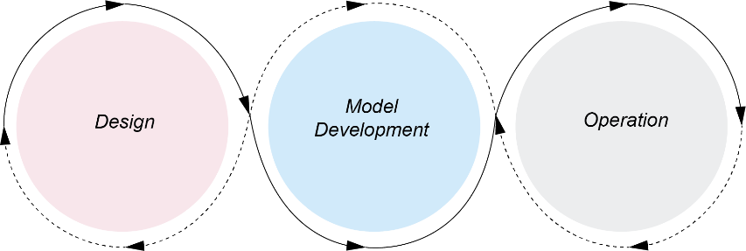

Design
- Defining the business problem to be solved
- Refactoring the business problem into a machine learning problem
- Defining success metrics
- Researching available data.

Model development
- Data wrangling
- Feature engineering
- Model training, validation, testing

Operations
- Model deployment
- Supporting operations/use
- Monitoring model performance.

Robotic Process Automation (RPA)
RPA uses software robots to automate repetitive, rule-based tasks. RPA mimics human actions by interacting with UI, handling tasks that follow structured logic and defined workflows. RPA struggles with handling complex, unstructured data and tasks that require cognitive decision-making.

How ML supports automation through RPA
ML models like NLP, NLU, and Computer vision models allow RPA bots to interpret and process unstructured data. NLU models can be used to understand human language. Additionally, ML models can analyse large datasets to identify trends and predict outcomes, enabling RPA bots to make adaptive decisions based on the changes in workflows. Therefore, with the increasing model performance over time, RPA bots have great flexibility that empowers greater accuracy in changing complex workflows.

E.g.:
RPA bots can use ML-powered OCR to extract insurance claim reasons and review claims based on past data to predict its potential to be approved.

Business Process Automation (BPA)
BPA is the use of technology to automate cross-system and cross-functional workflows that traditionally use predefined rules and processes. It typically involves multiple workflows and automates end-to-end complex business processes. It is limited in making business decisions that aren’t fully captured by predefined logic.

How ML supports automation in BPA
By analysing large volumes of historical data and current contexts, ML models can identify flexible patterns that guide nuanced decision-making, establishing more dynamic and responsive workflows without significant reprogramming. In this way, the efficiency of BPA is enhanced with greater accuracy. Using NLP and computer vision models, BPA can automate tasks that involve interpreting unstructured data.

E.g.:
In supply chain management, ML enhances BPA by predicting inventory levels based on past sales, current trends, and external factors like seasonality. Instead of manually adjusting orders or running reports, BPA systems equipped with ML automatically place orders or make recommendations to optimise stock levels and avoid shortages or overstocking.

Distinguish between artificial intelligence (AI) and machine learning (ML)

Artificial Intelligence (AI)
AI refers to the development of computer systems that can perform tasks typically requiring human intelligence. These tasks include reasoning, problem-solving, understanding natural language, perception (e.g., visual processing), and decision-making. AI aims to simulate or replicate aspects of human cognition and behaviour.

E.g.:
Siri uses AI to process and respond to voice commands, answer questions, and manage tasks like setting alarms or sending texts. AI enables these systems to understand natural language and simulate human-like conversations.

Machine Learning (ML)
ML is a subset of AI that learns from vast datasets, identifies patterns, and makes decisions with minimal human intervention. The performance should improve over time.

E.g.:
Netflix uses ML to recommend movies based on a user's previous choices. The more the user watches, the better the system becomes at suggesting content tailored to the user.

Explore models of training ML, including supervised learning, unsupervised learning, semi-supervised learning, and reinforcement learning.

Supervised Learning
Data Requirement: Labelled Data
Learning Type: Predictive or Classification
Algorithms: Linear Regression, Decision Trees, Support Vector Machines (SVM), Neural Networks.

E.g.:
A binary classification model is trained a dataset of spam and non-spam emails. Once trained, the model can predict whether a new email is spam.

Unsupervised Learning
Data Requirement: Unlabelled Data
Learning Type: Pattern recognition, Clustering
Algorithms: K-nearest neighbour, Principal Component Analysis (PCA).

E.g.:
Unsupervised learning can be used to group customers based on their buying behaviour, enabling businesses to target specific segments with personalised offers.

Semi-Supervised Learning
Principle: the labelled data helps guide the learning process while leveraging the abundance of unlabelled data to improve performance

Data Requirement: Mostly unlabelled data with a small portion of labelled data

Learning Type: Prediction, classification, pattern finding, clustering

Algorithms: Label Propagation, Semi-supervised Support Vector Machines (S3VM)

E.g.:
Labelling large image datasets can be time-consuming. Semi-supervised learning allows for the use of fewer labelled images while still achieving high accuracy in classifying new images.

Reinforcement Learning
Reinforcement learning involves training a model through interactions with an environment. The model, called an agent, learns by receiving feedback in the form of rewards or penalties based on the actions it takes. The goal is to learn a policy that maximises the cumulative reward over time. The model learns to make decisions by balancing exploration (trying new actions) and exploitation (using known actions that yield high rewards).

Algorithms: Deep Q-Networks (DQN), Proximal Policy Optimisation (PPO).

E.g.:
AlphaZero reinforcement learning models can be trained to play chess by rewarding the model for making moves that lead to a win.

Investigate common applications of key ML algorithms, including data analysis and forecasting, virtual personal assistants, and image recognition.

Data Analysis and Forecasting
ML algorithms can identify non-obvious patterns in large datasets.
E.g.:
Clustering algorithms, such as KNN, can allow businesses to segment customer groups based on purchasing behaviour or preferences.

Predictive models, such as time series algorithms and regression models, are used to make forecasts based on historical data.
E.g.:
In weather forecasting, recurrent neural networks (RNNs) are employed to model temporal data and predict future weather conditions based on past data patterns.

Virtual Personal Assistants
Virtual personal assistants use deep neural networks (DNNs) to convert spoken language into text, which is then processed by transformer models (e.g. BERT) for contextual understanding and intent recognition. Through reinforcement learning and collaborative filtering, they continuously adapt to user preferences, enabling more accurate, personalised responses and recommendations over time.

E.g.:
Virtual assistants might suggest music based on past music requests

Image Recognition
CNNs are used to identify patterns within images, making them effective for tasks like facial recognition, medical image analysis (e.g., detecting tumours in X-rays), and autonomous vehicle navigation.

Object Detection and Classification
Algorithms such as YOLO (You Only Look Once) are used to detect and classify objects within images. These are applied in areas like surveillance, where detecting suspicious items or identifying individuals is crucial, and in social media, where photos are automatically tagged based on face recognition.

Research models used by software engineers to design and analyse ML, including decision trees and neural networks.

Decision Trees
A decision tree is a visual representation that illustrates all possible combinations of decisions and their corresponding actions. It is commonly used in both classification and regression tasks in ML. The structure of the tree follows a sequence of decisions, where each decision path leads to either another decision or an outcome.

Key Strengths
Interpretability: The flowchart-like structure makes decision trees easy to understand and interpret, showing how decisions lead to specific actions.

Versatility: Decision trees are useful for a wide range of problems, particularly when the goal is to map out possible outcomes based on a set of conditions.

Limitations
Overfitting: Decision trees can grow too complex when trained on noisy data, leading to overfitting.

Instability: Small changes in the data can lead to a very different tree structure.

Common Use Cases
Classification: E.g., determining whether an email is spam or not.

Regression: E.g., predicting the price of a house based on its features like size and location.

Neural Networks
Inspired by biological neurons, Neural networks are a type of deep learning model that captures non-linear relationships, making them suitable for both structured (e.g., tabular) and unstructured (e.g., images, text) data.

Structure
Input Layer (e.g., pixel values in an image, numerical features in tabular data)

Hidden Layers
The layers between the input and output layers. A neural network can have multiple hidden layers. Each layer consists of neurons that apply an activation function to introduce non-linearity into the model, allowing it to learn complex patterns.

Common activation functions:
ReLU (Rectified Linear Unit): Sets negative values to zero and leaves positive values unchanged, making it highly efficient for deep learning models.

Sigmoid: Maps values between 0 and 1, often used in binary classification tasks.

Output Layer
The output layer produces the final prediction based on the learned weights and transformations.

Learning Mechanism
Forward Propagation
Data moves from the input layer, through the hidden layers, to the output layer. Each neuron applies a weighted sum of its inputs, passes the result through an activation function, and forwards the output to the next layer.

Loss Function
The loss function calculates the error between the predicted output and the actual target.

Backpropagation
Once the loss is calculated, the model adjusts the weights of the connections using an optimisation algorithm, typically gradient descent. Gradient descent updates the weights in the direction that minimises the error, with the learning rate controlling the size of the steps taken during each update.

Training and Convergence
The process of forward propagation, loss computation, and backpropagation is repeated iteratively over many epochs, minimising loss and improving overall performance.

Types of Neural Networks
Feedforward Neural Networks (FNN)
Data moves in one direction, from input to output, without cycles or feedback loops. It is used in regression or basic classification (e.g., predicting the outcome of a stock market price).

Convolutional Neural Networks (CNN)
CNNs have convolution layers that apply kernels to detect local visual features. Pooling layers are used to reduce the spatial dimension while keeping essential feature information. It is used in computer vision tasks like image classification (e.g., identifying objects in images), object detection (e.g., detecting faces in a picture), and video analysis.

Deep Neural Networks (DNN)
DNNs are NNs with many hidden layers to learn more complex features. They require a large dataset and computational power. It is used in complex recommendation systems (e.g., Netflix movie recommendations) and advanced AI systems like OpenAI's GPT.

Key Concept
Weight Initialisation
The initial values of the weights can significantly impact how fast the network converges. Poor initialisation may lead to vanishing gradients or slow training.

Regularisation techniques (prevent overfitting)
Dropout: Randomly drops a subset of neurons during training, forcing the network to learn more robust features.

Strengths of NN
Versatility: Can be applied to various tasks, from image recognition to language processing.

Representation Learning: Automatically learns features from raw data, reducing the need for manual feature engineering.

Scalability: Can handle massive datasets and is capable of scaling across distributed systems (e.g., cloud computing frameworks like TensorFlow or PyTorch).

State-of-the-Art Performance: Especially in tasks such as speech recognition, object detection, and game playing.

Limitations of NN
Data Hungry: Neural networks typically require large datasets for optimal performance. Small datasets may lead to overfitting and poor generalisation.

Computationally Intensive: Training deep neural networks is resource-heavy, requiring high-performance hardware such as GPUs or TPUs.

Black Box Nature: NN is a black box that lacks interpretability, making it hard to understand why a network makes certain decisions.

Overfitting: Without proper regularisation, neural networks may perform very well on training data but fail to generalise to new, unseen data.

Describe types of algorithms associated with ML, including linear regression, logistic regression, and K-nearest neighbour.

Regression
Regression is a type of ML algorithm used to predict continuous values by finding non-obvious patterns. It helps to understand the relationship between one or more input variables (features or independent variables) and an output variable (the dependent variable).

Linear Regression
Linear regression is a type of algorithm that helps predict continuous values through a linear relationship.

Logistic Regression
Logistic regression is used for classification tasks. Logistic regression predicts the probability of specific categories. The sigmoid activation function is used to convert any number into a probability between 0 and 1.
E.g.:
Predicting students pass or fail based on homework scores and study scores

K-Nearest Neighbour (KNN)
KNN is an algorithm used for both classification and regression. It predicts new outcomes by looking at the labels of the K Nearest Neighbours.

E.g.:
To determine whether a fruit is an apple or an orange based on its size and colour, KNN compares the fruit to the K nearest examples in the dataset.

Design, develop and apply ML regression models using an OOP to predict numeric values, including linear regression, polynomial regression, and logistic regression.

Why use OOP to design models?
The Traditional Regression model is written in procedural or declarative. With OOP, scalability is ensured through inheritance. Encapsulation keeps data and logic together. Structured models are enforced with abstraction to ensure maintainability. Polymorphism offers greater flexibility in modifying regression models.

Polynomial Regression OOP
- Inherit from LinearRegression to reuse logic for fitting and prediction.
- Additional Attribute: Degree of the polynomial.
- Method: transform() that converts input features into polynomial terms.

Logistic Regression OOP
- Inherit from LinearRegression.
- Methods: Implement the sigmoid activation and adjust the gradient descent to
- minimise the cross-entropy loss instead of MSE.

Model Type | Task Type | Equation Type | Use Cases
Linear Regression | Predicting continuous values | Linear equation | Predicting housing prices based on numbers of bedroom
Polynomial Regression | Predicting continuous values | Polynomial equation | Predicts non-linear relationships like temperature variation
Logistic Regression | Binary classification | Sigmoid | Binary outcomes like spam detection for emails

Apply neural network models using an OOP to make predictions.

By using an OOP approach, flexible and reusable neural network models can be defined. The structure of the class will allow for flexibility in modifying the network's architecture and training process.

OOP allows for encapsulating the functionality of the neural network into a single class. This class can manage the network's architecture (layers, neurons, weights, and biases), the forward and backward passes, and the training loop.

Attributes
Layers
Define the architecture of the neural network (e.g., input layer, hidden layers, output layer).

Weights and Biases
Initialise random weights and biases for the connections between neurons in different layers.

Learning Rate
Controls how much the model's weights are updated with respect to the error gradient during training.

Assess the impact of automation on the individual, society and the environment, including safety of workers, people with disability, the nature and skills required for employment, production efficiency, waste and the environment, and the economy and distribution of wealth.

Safety of Workers [Individual]
By replacing humans in dangerous tasks, automation significantly reduces the risk of injury or fatality. However, automation introduces new safety risks related to technical malfunctions.

E.g.:
Autonomous haulage systems are used to reduce the risks miners face from potential cave-ins and the toxic environment. Yet, when a robotic arm malfunctions, it can endanger the workers working on the same factory line.

People with Disability [Individual]
Automation offers significant opportunities to improve the lives and employment prospects of people with disabilities through assistive technologies. Nevertheless, automation risks displacing people with disability in roles that involve repetitive tasks

E.g.:
Robotic exoskeletons enable people with mobility impairments to walk again, allowing individuals who were previously excluded from physically demanding jobs to participate in the workforce. On the other hand, previous factory workers with cognitive disabilities are displaced unless retraining initiatives are created.

The Nature and Skills Required for Development
Automation is displacing roles that involve repetitive or predictable tasks. It is creating demand for skilled workers in fields such as AI and data science, necessitating workers to upskill in more skilled roles continuously.

E.g.:
Factory workers are getting replaced by robotic arms, with new employment opportunities for robotics engineers to maintain the automated systems.

Production Efficiency, Waste and Environment [Environment]
Automation increases production efficiency, leading to cost savings and higher output. By using automated systems that minimise faulty processes, less waste is produced. However, it also raises environmental concerns, particularly when energy use is elevated.

E.g.:
Tesla’s Gigafactory automates vehicle production and operates 24/7, increasing production time and costs. Precision manufacturing from the robotic arms ensures minimal material loss. Nevertheless, it uses large amounts of energy, which is an environmental concern.

Economy and Distribution of Wealth [Society]
While automation drives economic growth by increasing productivity, it poses significant challenges to the fair distribution of wealth. Automation tends to disproportionately benefit capital owners and highly skilled workers, potentially widening the wealth gap between the rich and the poor.

In response, some governments like Finland are exploring policies like universal basic income (UBI) to mitigate the economic displacement caused by automation.

E.g.:
Amazon utilises robots to transport products within its warehouses, enabling sales to scale rapidly and support better company growth. However, this leads to job displacements for low-skilled workers, where the wealth generated primarily benefits Amazon’s shareholders and executives.

Explore by implementation how patterns in human behaviour influence ML and AI software development, including psychological responses, patterns related to acute stress response, cultural protocols, and belief systems.

AI developers create algorithms that analyse data and also interact effectively with users, reflecting human behavioural patterns.

Psychological Responses
Trust and User Adoption
Users are more likely to adopt AI systems if they trust the recommendations or decisions made by the system. Trust is built through transparency and reliability.

E.g. Medical AI need to justify their diagnosis, increasing user adoption and transparency.

Fear and Resistance
Psychological fear of AI can affect how users interact with AI systems. Developers need to create systems that feel intuitive and friendly to reduce resistance.

Cognitive Bias
AI systems must be designed to account for human cognitive biases.

E.g.: users may experience confirmation bias, where they favour AI outputs that confirm their pre-existing beliefs.

Acute Stress Response
In high-stress situations where cognitive load is already elevated, users need quick, straightforward solutions, so AI systems should minimise mental effort by providing clear, concise outputs instead of complex, data-heavy recommendations.

E.g.:
In AI-driven disaster management systems, simplified formats are used where visual alerts and concise instructions are prioritised to help first responders make quick, informed decisions under pressure.

Cultural Protocols
To ensure the technology is respectful and acceptable within cultural contexts, AI systems should be tailored to align with the cultural practices and expectations of the target users. This can include language preferences, gender roles, or traditional values that differ across cultures.

E.g.:
Google Assistant undergoes significant cultural adaptation when being deployed in different countries. These systems are programmed to recognise local dialects and respect local customs by addressing people more formally in certain cultures.

Belief Systems
Developers must account for belief systems to avoid ethical conflicts and ensure that AI systems operate within acceptable moral boundaries. AI systems must be designed to avoid bias, especially in culturally diverse societies. Developers should incorporate fairness and inclusivity into AI algorithms, ensuring that systems do not discriminate based on belief systems.

E.g.:
In facial recognition technology, ethical AI development considers potential biases against specific racial or ethnic groups, ensuring the technology works equally well across different demographics.

Investigate the effect of human and dataset source bias in the development of ML and AI solutions.

Bias arises when the models, data, or decisions made by developers unintentionally favour certain outcomes, groups, or perspectives over others.

Human Bias
Human bias refers to the implicit and explicit preferences or assumptions that developers may hold, which can influence the design and decision-making processes involved in creating AI systems.

Feature Selection Bias
The choice of variables or features for a model can reflect the developer's priorities or preconceived notions about what is important.

E.g.: If socio-economic status is prioritised as a feature in predictive models for employment, the model may perpetuate existing inequalities.

Algorithm Design Bias
Developers might unintentionally favour certain algorithmic structures or processes that reflect their own experiences or goals, even if those structures introduce bias.

Dataset Source Bias
Dataset bias occurs when the data used to train machine learning models is not representative of the broader population or task.

Historical Bias
This occurs when the dataset reflects past inequalities or discrimination.

E.g.: If a hiring algorithm is trained on historical data from an industry with low gender diversity, it may learn to favour male candidates over female candidates.

Sampling Bias
If certain groups are overrepresented or underrepresented in the dataset, the model will generalise poorly to the underrepresented groups.

E.g.: Medical AI systems trained on data from one demographic may fail to diagnose or recommend treatments for another accurately.

Labelling Bias [Both human and Dataset]
During the creation of datasets, humans often label data (e.g., tagging images or categorising information). Their labels may reflect personal biases, reinforcing stereotypes or errors.

Consequences of Bias in AI Systems
Discrimination
Biased AI systems may discriminate against certain groups based on race or gender.

Reduced Trust
Users and society may lose trust in AI systems if they consistently produce unfair or biased outcomes.

Poor Decision-Making
Bias in models can lead to inaccurate or inappropriate decisions.

Legal and Ethical Implications
Many countries have anti-discrimination laws, and biased AI systems could lead to legal challenges. Furthermore, there are growing concerns about the ethical responsibility of organisations deploying AI systems.

Mitigating Bias in AI Development
Diverse Teams [Human Bias]
Building teams with diverse perspectives can help mitigate bias by ensuring that different viewpoints are considered during AI development.

Algorithmic Fairness [Human Bias]
Using fairness-aware algorithms that aim to equalise outcomes for different groups can be an effective mitigation strategy.

Bias Audits and Testing [Data Bias]
Conducting audits and testing models for bias across different demographic groups can help identify and correct biased behaviour.

Inclusive Datasets [Data Bias]
Curating and using datasets that are representative of the entire population can help prevent dataset bias. This might include collecting additional data for underrepresented groups.

E.g.:
To reduce gender bias in hiring algorithms, companies anonymise candidate resumes and train models on more inclusive datasets that do not reflect historical gender biases.

Software Engineering Project

Define and analyse the requirements of a problem, including demonstrating need(s) or opportunities, assessing scheduling and financial feasibility, generating requirements including functionality and performance, defining data structures and data types and defining boundaries.

The process of defining and analysing a problem's requirements is critical because it influences the project's outcome. Requirements are a system's specific features to solve a problem. They provide clear, measurable goals to guide development and ensure the system meets user needs and can be tested for success.

Step 1: Demonstrating Needs or Opportunities
Why is the project needed?
- Conducting a feasibility study
- Interviews with stakeholders to understand their needs.
- Questionnaires to gather input from a wide range of users.
- Observations of current systems or processes to pinpoint inefficiencies.

Step 2: Scheduling and Feasibility
By assessing both scheduling and financial feasibility, the development team ensures that the project remains within scope and can be delivered on time and within budget.

- Scheduling feasibility - estimating the duration of the project, Gantt Chart
- Financial feasibility – estimating developmental costs and comparing them with the budget.

Step 3: Generating Requirements
Specific requirements in terms of functionality and performance should be generated and documented in a software requirements specification (SRS), which will be a reference throughout the development process.

- Functional requirements describe the specific actions the system must perform.
- Performance requirements specify how well the system should perform these functions.
E.g.: Speed, Reliability, Scalability

Step 4: Data Structures and Data Types
Defining the data structures and types is essential for fast, efficient, reliable data management and processing.
E.g.: Product names are strings and quantities are integers in an inventory management system.

Defining Boundaries
Defining a system's boundaries controls the project's scope, preventing scope creep and added expenses.

Explore tools used to develop ideas and generate solutions, including brainstorming, mind-mapping and storyboards, data dictionaries, selecting appropriate data types, algorithm design, code generation, testing and debugging, installation, and maintenance.

Brainstorming, mind-mapping and storyboards
Brainstorming helps generate ideas and explore potential solutions. It involves team members contributing their thoughts freely. Mind mapping allows developers to structure information non-linearly, showing how different concepts are connected.

Algorithm Design
Algorithm design involves creating step-by-step instructions to solve a specific problem. Effective algorithms are designed to be both efficient and scalable.

Code Generation
Code generation is the process of translating the algorithm or system design into actual code in a programming language.

Testing and Debugging
Testing involves running the program under various conditions to identify any issues or bugs.
- Unit testing: Testing individual components or functions.
- Integration testing: Ensuring that different modules of the system work together correctly.
- System testing: Testing the entire system to verify that it meets the requirements.

Installation
Installation is the process of transferring the software from the development environment to the end-user environment. It often involves setting up databases and configuring hardware. Thorough documentation and testing of the installation process are essential to ensure the system works as intended in the target environment.

Maintenance
Maintenance is the ongoing process of updating and improving the software after its installation. Effective maintenance ensures the software meets user needs and remains relevant in a changing technological landscape.

- Corrective maintenance: Fixing problems or defects that arise post-deployment.
- Adaptive maintenance: Updating the software to work in a new or changing environment (e.g., when hardware or operating systems are updated).
- Perfective maintenance: Enhancing or adding new features to improve performance or functionality.

Investigate types of software implementation methods, including direct, phased, parallel, and pilot.

Direct
In direct conversion, the old system is entirely replaced by the new system at a specific time. This is used when it is impractical to operate both systems simultaneously.
- Fast and clean – Do not need to maintain two systems at once
- Must be thoroughly tested or at risk of operational disruptions with no backup systems
- Users must be fully trained before the switchover.

E.g.: A bank installing new ATMs with new touch screen features would use direct conversion. It would be impractical to have old and new ATMs operating side by side, as it would confuse customers and duplicate work.

Parallel
Parallel conversion involves running both the old and new systems simultaneously for a period.
- Allows users to gradually familiarise themselves with the new system while retaining the security of the old system.
- Has the old system as a backup if problems occur with the new system.
- Resource-intensive, as both systems must be maintained for operation until the new system meets requirements.

E.g.: A hospital installing new life support systems uses parallel conversion. Staff would continue to monitor patients manually while becoming familiar with the automated monitoring system, ensuring patient safety throughout the transition.

Phased
In phased conversion, the new system is introduced gradually, often in stages. As parts of the new system are implemented, the corresponding parts of the old system are removed.
- Useful for large or complex systems where implementing everything at once would be overwhelming or risky.
- Allows users to adapt gradually, reduces the likelihood of errors, and makes the process more manageable for developers and users.
- It takes longer than other methods, and coordination between different system parts is crucial.

E.g.: A school can use phased implementation to implement a learning management system, using it in selected classes for marking rolls to eventually marking assignments, ensuring each module’s functionality before implementing the next module.

Pilot
The pilot conversion method involves installing the new system for a small group of users before rolling it out to the entire organisation. This allows the system to be tested in a real-world environment, providing valuable feedback to developers and ensuring that any issues are addressed before full-scale implementation. The pilot users can also assist in training others when the system is eventually rolled out.

Used for new or highly complex systems where there is uncertainty about how the system will perform under real-world conditions. It limits the impact of any issues to a small group.

E.g.: A new ticketing system for a travelling circus could be piloted at a single location to ensure it works properly before being used across all venues.

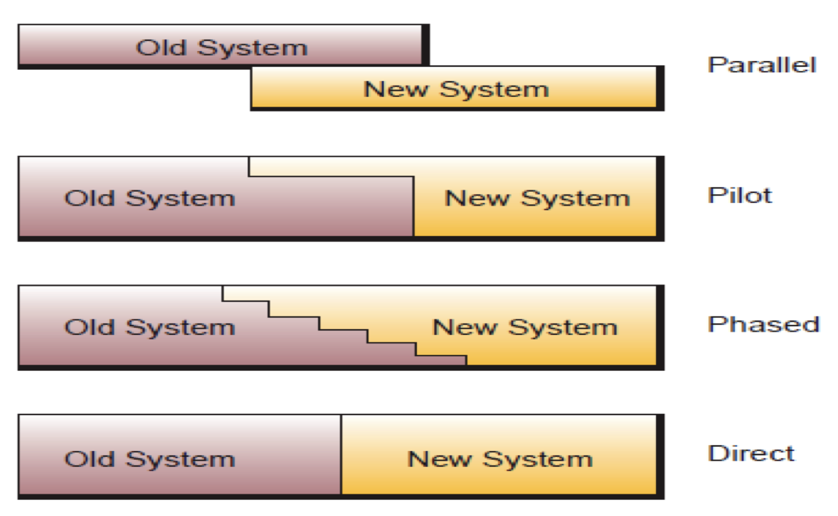

Research and use the Waterfall software development approach, including logical progression of steps used throughout the life cycle, stages of ‘falling water’, advantages and disadvantages and scale and types of developments.

Refer to the above notes.
The Waterfall approach is a traditional, linear methodology where each phase of the project must be completed before moving on to the next.

Advantages
- The clear linear structure is easy to follow and manages large teams with different skill sets, as each team knows precisely what is expected at each stage.
- The developers and stakeholders have a shared understanding of the project's goals, where requirements are fully documented before the project starts.
- A structured approach ensures every aspect of a large-scale project is meticulously planned and executed.

Disadvantages
- Inflexibility: it is difficult to go back and make changes without causing delays and increasing costs.
- Late Testing: Issues or defects may not be discovered until the completion of the developmental phase.
- Poor Adaptation to changes in requirements
- Longer timeframes because of the sequential nature of the Waterfall

Scale and Types of Developments
The Waterfall approach is typically used for large-scale and complex projects where the requirements are well understood from the outset and unlikely to change. These projects involve significant time, money, and resources, and usually have strict performance, safety, or regulatory requirements.

E.g.:
Aviation software that requires extensive testing and validation is well-suited to Waterfall due to its structured, rigorous testing phase.

Research and use the Agile software development approach, including the rate of developing a final solution, method tailoring, iteration workflow, and scale and types of development.

Agile is a flexible and iterative approach to software development that focuses on delivering small, functional increments of a solution quickly while continuously adapting to changes based on user feedback and collaboration.

Rate of Development
Agile is fast at delivering working versions of solutions through fast iterations. Each iteration focuses on delivering a functional increment of the software, allowing the team to respond quickly to changing requirements or feedback.
- The Minimum Viable Product is released ASAP.
- Agile ensures that the project delivers value even before it's fully complete.

Method Tailoring
Method tailoring refers to the flexibility Agile offers in adapting its developmental process to suit the project's unique demands rather than adhering to rigid guidelines.

Agile includes a variety of frameworks with flexibility in their cores. By mixing frameworks, the developmental process can be customised.
- Scrum: Often used for complex projects, it emphasises short, time-boxed iterations called sprints, with regular meetings (e.g., daily stand-ups) to keep the team on track.

Iteration Workflow
Agile development is conducted through short, repeatable development stages called iterations. Each iteration results in a working software version that stakeholders can test, review, and evaluate.
- Planning
- Design and Development
- Testing
- Feedback and Evaluation
- Iterative Cycle

Scale and Types of Developments
Agile is highly adaptable and can be applied to both small and large-scale projects
- Small Projects: The flexibility of small teams allows for quick decision-making and fast adaptation to change.
- Large Projects: Agile can be applied by breaking the project down into smaller, self-organising teams focusing on a component or feature of the larger system.

E.g.:
- Mobile and Web applications

Research the WAgile software development approach, including understanding it is a hybrid model, analysis of the ‘when’ and ‘how’ intervention is applied during the development life cycle, and scale and types of developments.

WAgile is a hybrid software development approach that combines the structured, linear nature of the Waterfall methodology with the flexible, iterative elements of the Agile methodology.

Understanding WAgile as a Hybrid Model
WAgile combines the predictability of Waterfall with the adaptability of Agile. WAgile integrates both by starting with the structured planning and documentation from the Waterfall approach, which provides clarity and a roadmap for the project. Then, Agile’s iterative development cycles are incorporated into the later stages of development, allowing for flexibility, regular feedback, and adaptation to change. This makes WAgile suitable for projects that need a balance between formal planning and flexibility in execution.

When and How Intervention Is Applied During the Development Lifecycle
 | When | How
Initial Planning Phase | Pre-planned reviews | Flexible intervention at end of each cycle
Iterative Phase | Early structured checkpoints | Daily stand-ups, sprint reviews

Scale and Types of Developments
WAgile is suited to medium- to large-scale projects where both structure and flexibility are needed. The hybrid approach works well when the project’s requirements are well-defined upfront, but are expected to change during the development process.
- Small-scale projects: WAgile’s overhead of initial planning may be excessive.

E.g.:
- Large-scale web applications

Apply project management to plan and conduct the development and implementation of a project and software engineering solution, including scheduling and tracking using a software tool, including Gantt charts, using collaboration tools.

Project Management Tools
- Gantt chart
- Version control system
- Logbook
- Installation guide
- Technical Manual

System Modelling Tools
- DFD Level 0
- DFD Level 1
- Pseudocode
- Structure Chart
- UML
- Data dictionary
- Flowchart
- ORM

Explore social and ethical issues associated with project work, including working individually, collaboratively and responding to stakeholders.

Working Individually [Ethical]
Without input from others, individuals allow personal biases to influence the design and implementation of the project, potentially overlooking vital details. Ethically, it’s important to challenge one's assumptions and seek feedback from external sources when necessary.

Working Collaboratively [Ethical]
An ethical approach to teamwork involves ensuring that tasks are distributed fairly among team members based on their skills and capacities.

Responding to Stakeholders [Ethical]
Ethical project management requires prioritising the needs and safety of users, ensuring that the software does not harm them or compromise their privacy and data.

Explore communication issues associated with project work, including involving and empowering the client, enabling feedback, and negotiating.

Involving and Empowering the Client
Involving the client early and consistently ensures that the final product aligns with their vision and needs. It also enhances the client’s trust in the project team and allows for smoother collaboration.

Strategies to Empower the Client
- Provide the client with detailed project plans, timelines, and updates
- Regularly delivered prototypes help clients visualise progress and meet their needs.
- Visibly act on Feedback

Negotiating
Negotiation plays a key role in resolving conflicts and ensuring that both the client and the development team are satisfied with the project's direction, helping balance the client’s desires with the realities of development.

Effective Negotiation Techniques
- Understand Both Sides
- Focus on Solutions
- Be Transparent
- Set Clear Boundaries
- Any negotiated changes to the project should be documented

Investigate how software engineering solutions are quality assured, including defining criteria on which quality will be judged, ensuring requirements are met using a continual checking process, addressing compliance and legislative requirements.

Quality Assurance (QA) is a systematic process that ensures a software product meets defined quality standards. QA also addresses legal and regulatory compliance, ensuring the software is functional, safe, and lawful.

E.g.: QA of a mobile application would test key performance metrics such as scalability against the requirement definition.

Other

Procedures and Functions

Functions
Functions are blocks of code that take inputs, perform a specific task and return a value. Its main purpose is to produce a value based on the inputs provided.

Procedures
Void functions are blocks of code that take inputs and perform a task but do not return a value. Its main purpose is to execute commands.

Errors
Syntax Error: Code violates the rules of the programming language

Logic Error: Code runs but doesn’t produce the expected output due to flawed logic

Runtime Error: Serious problem as the program is running due to incorrect assumptions

OOP, imperative, logic and functional Programmingc Paradigms

A paradigm is a way of programming thinking. It is a model or theoretical framework.

Imperative programming:
- Code consists of a sequence of commands that change the state of a program.
- It tells the computer "how" to perform a task by specifying a step-by-step process.
- The focus is on changing variables and memory locations to achieve the desired outcome.
- Example languages: C, Pascal

move_forward(10);
elevate_arm(90);

Object-oriented programming (OOP):
- Focuses on organising code into "objects," representing real-world entities or abstract concepts.
- Objects contain data (attributes) and behaviour (methods).
- Example languages: Python, Java

import abc

class Animal(abc.ABC):
def __init__(self, name, species):
self._name = name # encapsulation
self._species = species

@abc.abstractmethod #abstraction
def make_sound(self):
pass

def get_info(self):
return f"{self._name} is a {self._species}."

class Dog(Animal): #Inheritance
def __init__(self, name, breed):
super().__init__(name, species="Dog")
self._breed = breed

def make_sound(self):
return "Woof!"

def get_info(self): #polymorphism
base_info = super().get_info()
return f"{base_info} It is a {self._breed} breed."

dog = Dog(“Daniel”,”dog”)
dog.get_info()

Logic programming:
- Relies on logical relationships, rules and constraints. The program searches for a solution that satisfies these constraints.
- It focuses on the "what" rather than the "how" and is mainly used for symbolic computing, artificial intelligence, and expert systems.
- Example language: Prolog

% Facts
parent(john, mary).
parent(mary, susan).

% Rules
grandparent(X, Y) :- parent(X, Z), parent(Z, Y).

Functional programming (FP):
- Treats computation as the evaluation of mathematical functions.
- It avoids changing state and mutable data, emphasising immutability and using pure functions without side effects.
- FP promotes more predictable code, is easier to test, and is less prone to bugs.
- Example languages: Haskell

factorial :: Integer -> Integer
factorial 0 = 1
factorial n = n * factorial (n – 1)

Paradigm | Strengths | Weaknesses
Imperative | - Efficient  - Close to the machine hardware  - Relatable in real world | - Difficult debugging  - Limited abstraction  - Necessity of order  - Poor reusability
OOP | - High degree of modularity  - Easily understood | - Only benefits problems with the need for re-usable code and those that are not sequentially driven
Logic | - The system solves the problem, so the programming steps are kept to a minimum  - Proving the validity of a given program is simple | - Difficult to code complex programs
Functional | - Focus on high-level design  - Flexible and reusable  - Easier to test and debug | - More memory usage  - Less expertise and tools that support this paradigm

Compare procedural programming with OOP.

Procedural-Oriented Programming (POP) | Object-Oriented Programming (OOP)
The program is divided into functions | The program is divided into objects
Doesn't use Access Modifiers | Makes use of Access Modifiers 'public', 'private', 'protected'
It is less secure | It is more secure
Data can move freely from function to function within programs | The object can move freely within member functions
It does not support inheritance | It supports inheritance

Encapsulation
Encapsulation allows programmers to hide attributes within a class to promote data security. These attributes are typically hidden and only accessible and modifiable through well-defined interface methods (getter and setter methods). It organises the variables and methods within classes.

Inheritance
Inheritance allows classes to inherit attributes and methods from other classes. This enables a hierarchical structure of classes where child classes can reuse and extend the functionality of their parent class. The child class doesn’t have to redefine the attributes and methods of the parent classes to use them. The child class is a more specialised version of the parent class. Inheritance is an “is-a” relationship.

Polymorphism
Polymorphism is a concept that allows classes to behave in different ways without changing the interface in which they are used. Inheritance enables polymorphism, and polymorphism allows the redefinition of methods in inherited classes to perform a single action differently. This is also called method overriding.

Generalisation and Abstraction
Generalisation
Generalisation is finding common traits among various specific classes and creating a general class from these traits. It aims to reduce copied code and promote maintainability and reusability.

Abstraction
Abstraction is the action of hiding implementation details and focusing on the essential ideas of a class rather than the specifics. Generalisation typically uses abstraction to create generic classes.

When an abstracted class is created either through abstraction or generalisation, it cannot instantiate objects.

Stubs and Drivers
Stubs are placeholders for low-level functions that mimic the expected behaviours of these functions to allow top-down level integration testing.

Drivers are placeholders for top-level modules that integrate low-level functions, allowing bottom-up system testing.

Intrinsic Documentation – Code comments, inline documentation

Skills

IPO
Input | Process | Output

Structure Chart
Structure charts are used to model the relationship between modules within a system. Using a hierarchical format, they can map the sequence of processes, data movement, and control parameters for interpretation. A structure chart can represent the control structure of sequence, selection, and iteration.
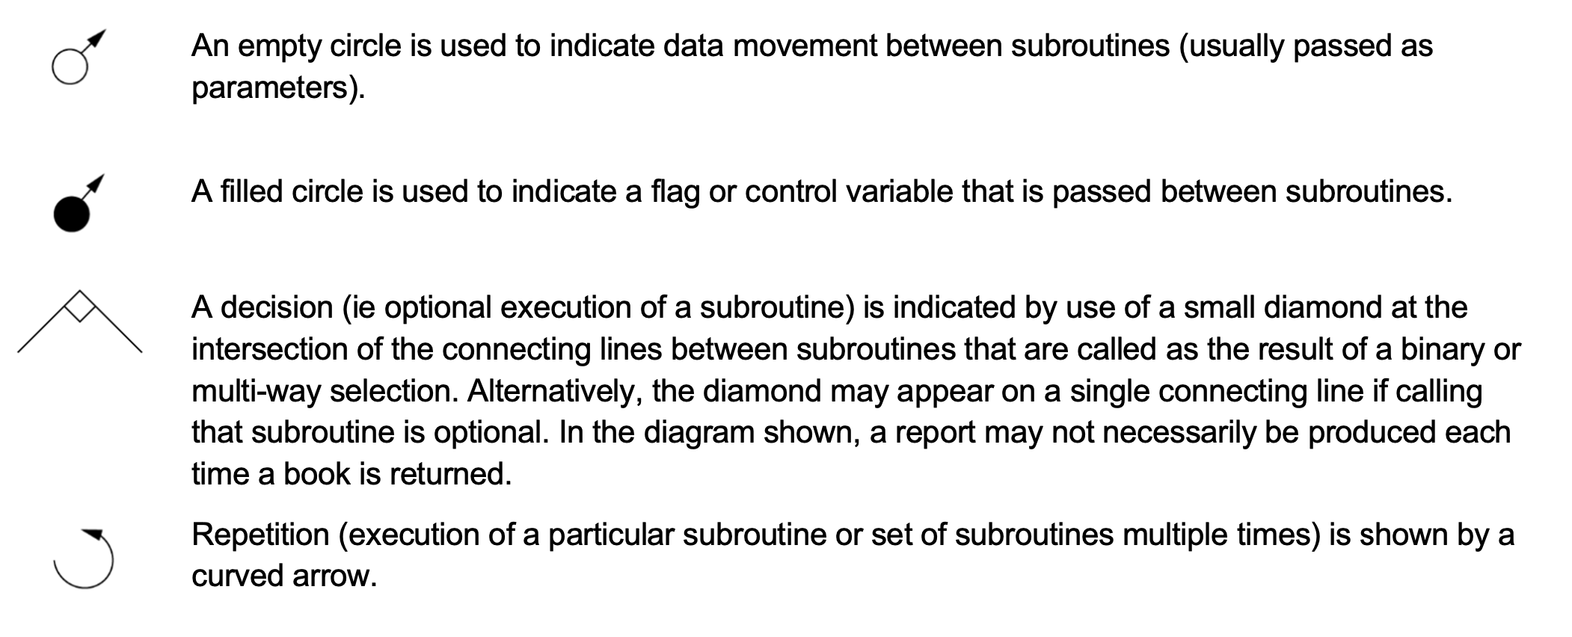
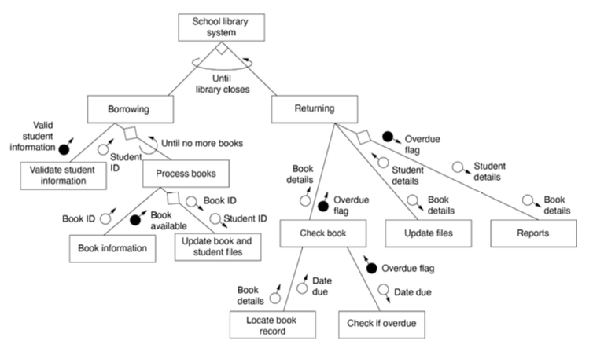

Pseudocode and Flowchart

Key Points
- Additional Keywords: LET, Display, RETURN, GET, BEGIN, END
- Array: use array()
- Underline subroutine usage in both FLOWCHART and PSEUDOCODE
- Don’t underline the subroutine name in both FLOWCHART and PSEUDOCODE
- BEGIN _ and END _. _ should reflect the program purpose

Symbol
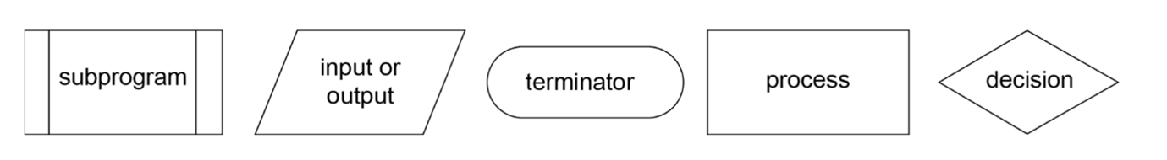
Psuedocode | Flowchart
IF condition A THEN  process 1  ELSEIF condition B THEN  process 2  ELSEIF condition C THEN  process 3  ELSE  process 4  ENDIF | 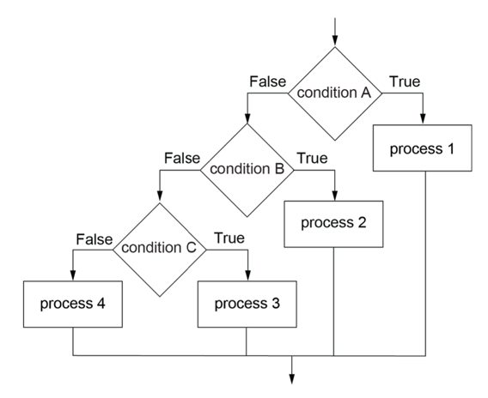
CASEWHERE expression evaluates to  choice a: process a  choice b: process b  ...  OTHERWISE: default process  END CASE | 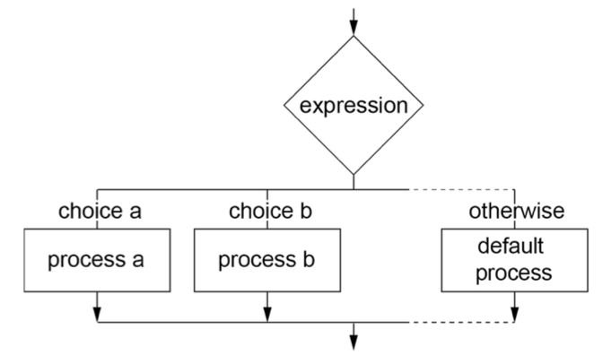
WHILE condition is true  process  ENDWHILE | 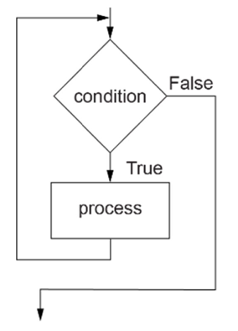
REPEAT  process  UNTIL condition is true | 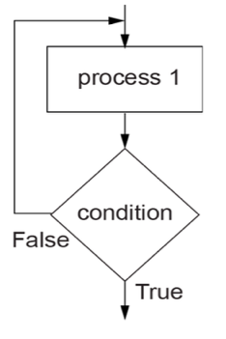
FOR variable = start TO finish STEP inc  statements  NEXT variable | 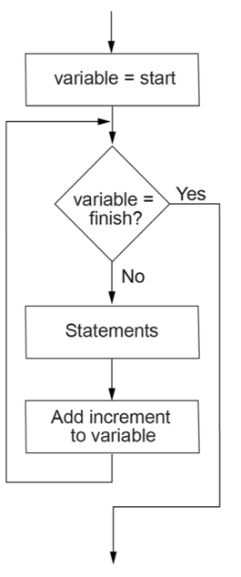

Data Flow Diagram
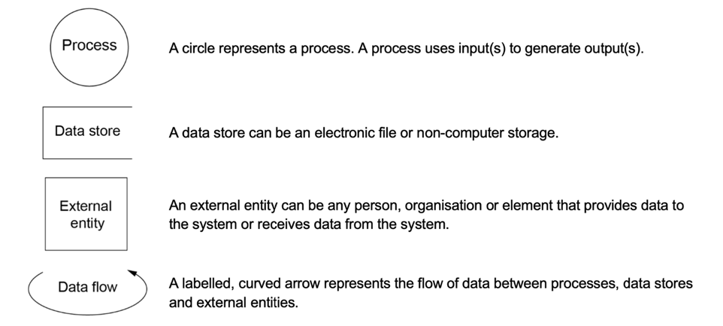
Always label data flow
Level 0 Data Flow should only have one Process named “___ System”

Desk Check
Line number | Input | Var1 | VarI | Output
Blank for non-instantiation
Fill for all instantiated variables regardless of if it has been changed within the line.

Data Dictionary
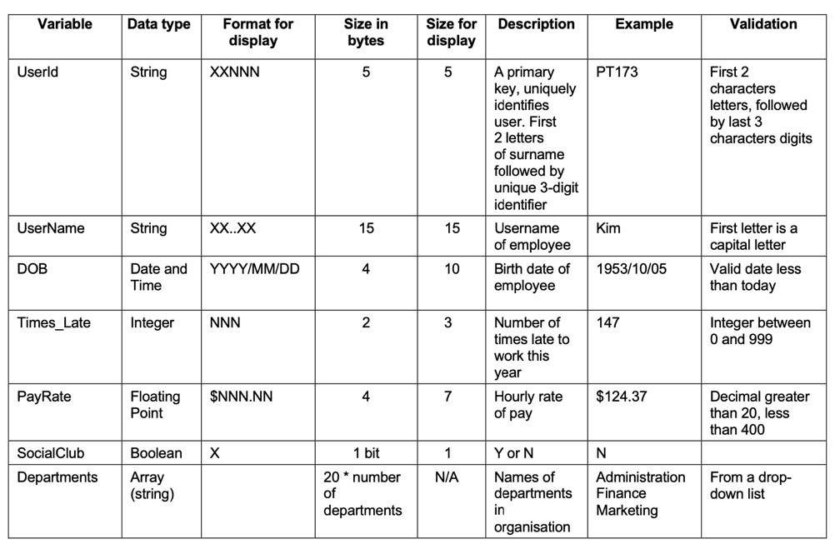

Class Diagram
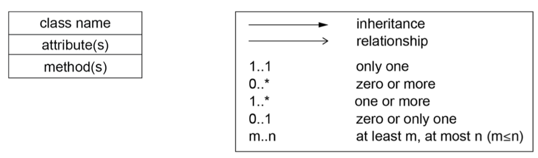
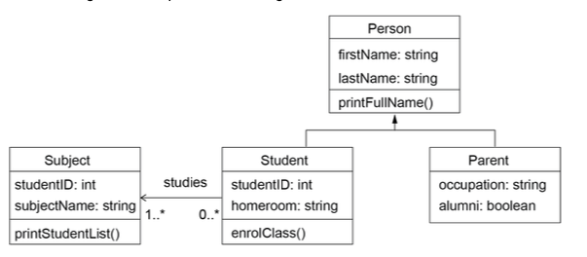

Gantt Chart
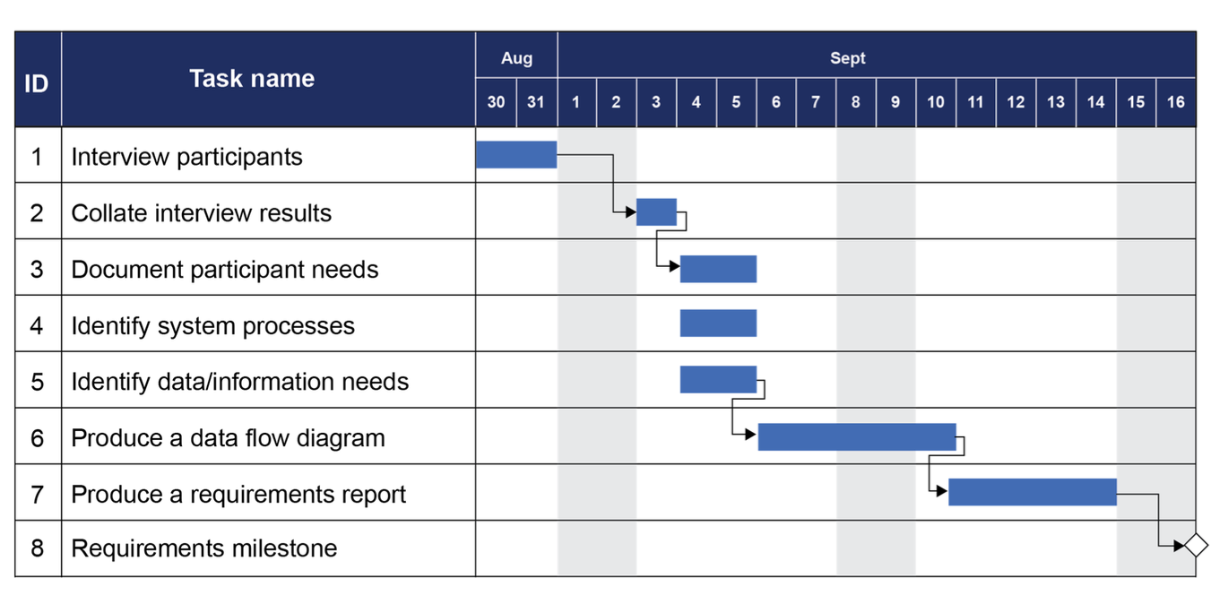

SQL
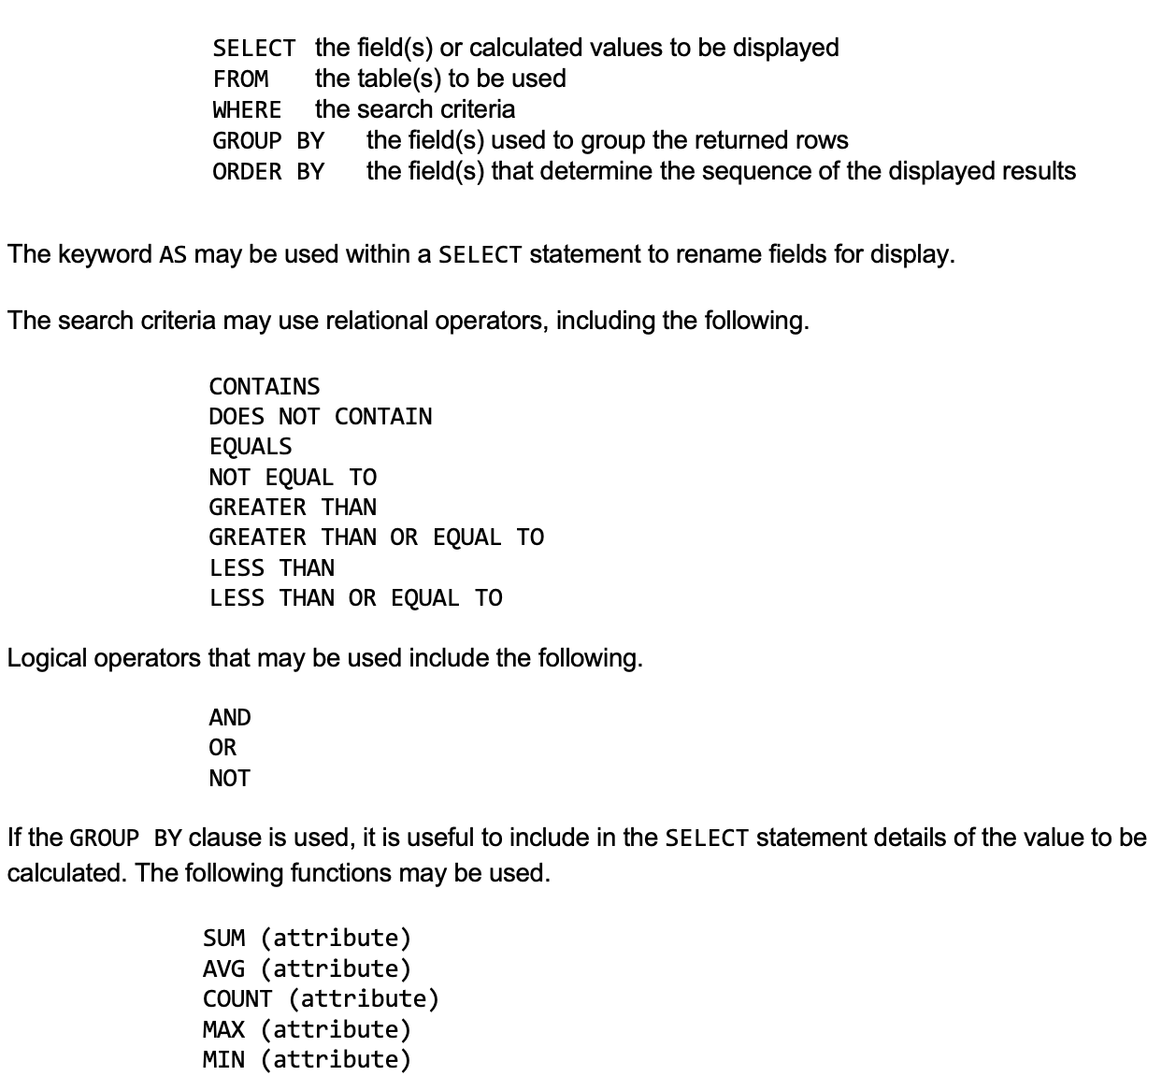

ERD


Wiring Diagram
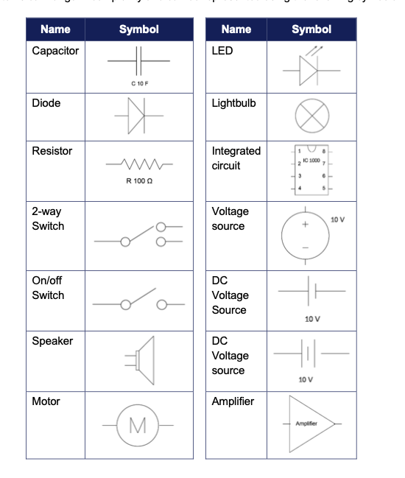

MLOps
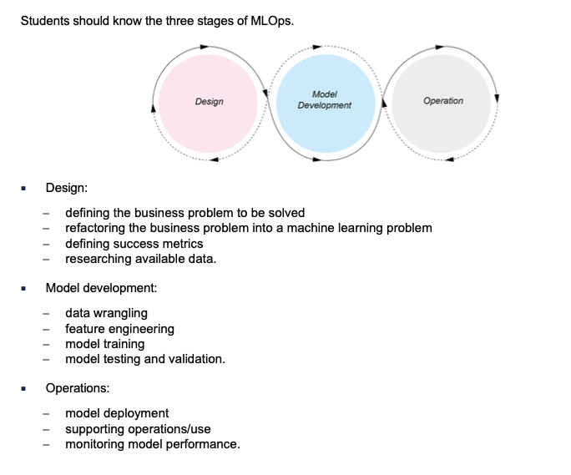

Regression Model
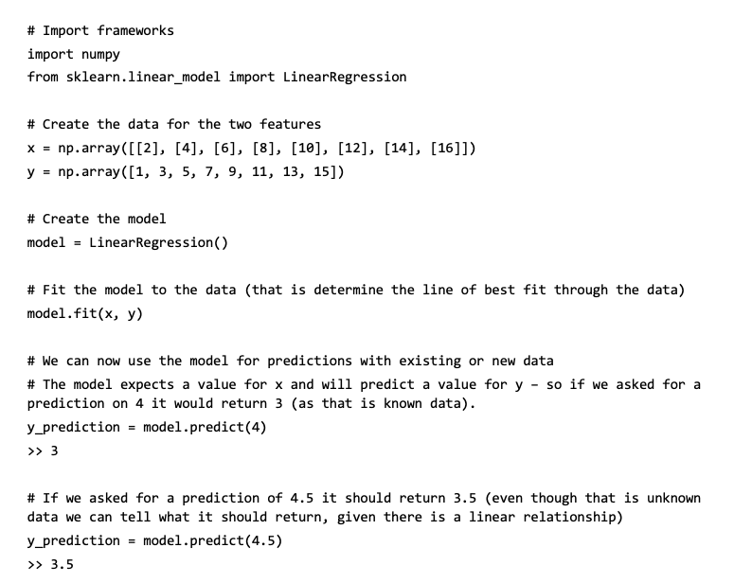

Python
Core Built-ins
len(x) # length of iterable
max(x), min(x) # largest / smallest
sum(x) # sum of numbers
sorted(x, key=..., reverse=True) # returns sorted list
all(x) # True if all elements truthy
any(x) # True if any element truthy
range(start, stop, step) # sequence generator
type(x) # object type
int(x), float(x), str(x), complex(x) # type conversions
list(), tuple(), set(), dict() # convert/construct
zip(a, b) # pair elements
enumerate(x) # (index, value) pairs
bin(n), hex(n) # convert to binary/hex string
ord(c), chr(i) # char ↔ Unicode code point

Strings
s.upper(), s.lower() # case change
s.isupper(), s.islower() # case checks
s.isdigit(), s.isalpha(), s.isalnum(), s.isdecimal(), s.isnumeric()
s.startswith(sub), s.endswith(sub) # prefix/suffix check
s.count(sub) # count occurrences
s.find(sub), s.index(sub) # find substring (-1 vs error)
s.replace(old, new) # replace substring
s.strip(chars), s.lstrip(), s.rstrip() # remove whitespace/chars
s.split(sep) # split into list
sep.join(list) # join list → string
len(s) # string length
s[0], s[-1] # indexing
s[a:b:c] # slicing with step

Lists
l.append(x) # add single element
l.extend(iterable) # add multiple elements
l.insert(i, x) # insert at index
l.remove(x) # remove first occurrence
l.pop(i) # remove & return element (default last)
l.count(x) # count occurrences
l.index(x) # find index of element
l.sort(key=..., reverse=True) # sort in place
l.reverse() # reverse list
del l[i] # delete element
list(reversed(l)) # reversed copy
list(zip(a, b)) # zip back into tuples

Tuples
t = (1, 2, 3) # tuple creation
x, y = (1, 2) # unpacking
t.count(x), t.index(x) # count / index

Sets
s.add(x), s.update(iterable) # add elements
s.remove(x), s.discard(x) # remove (discard = safe)
s | t # union
s & t # intersection
s - t # difference
s ^ t # symmetric difference

Dictionaries
d.get(key, default) # safe retrieval
d.keys(), d.values(), d.items() # views
d.update({k:v}) # add/update multiple
d.pop(key), d.popitem() # remove & return
d.clear() # empty dictionary
d[k] = v # add/update key
del d[k] # delete key

for k in d: print(k) # keys
for v in d.values(): print(v) # values
for k, v in d.items(): print(k, v) # key + value pairs

File Handling
f = open("file.txt", "r") # open file
f.read(), f.readline(), f.readlines() # read content
f.write("text"), f.writelines(list) # write content
f.close() # close file
with open("file.txt") as f: # auto-close
data = f.read()

User I/O
name = input("Enter name: ") # input from user
print(a, b, sep="*", end="\\") # custom print

Errors & Exceptions
try:
# risky code
except ValueError:
# handle specific error
except:
# handle any error
else:
# if no error
finally:
# always run

Math / Random / Useful Modules
import math
math.pi
math.sqrt(16)
math.ceil(x)
math.floor(x)

import random
random.random() #random float between 0 and 1
random.randint(a, b) # random int
random.choice(list) # random element

